Programme Development Policy and Guidance

Programme and Module Development, Approval, Amendment and Withdrawal
Table of Contents
1. Overview 5
2. Aim 6
3. Scope 7
4. The Life Cycle and Approval Timeline 8
5. Support and Engagement: the Quality and Academic Standards Team 10
6. General Principles 11
Student engagement 13
7. Roles & Responsibilities 14
Programme Approval Group (PAG) 14
Quality & Academic Standards Committee (QASC) 14
School Executive Group (SEG) 15
School Programme & Partnership Agreement Development Committee (PPADC) 15
School Quality & Academic Standards Committee (SQASC) 15
School Research Management Group 15
Course Operations Group (COG) 16
Global Partnerships 16
Legal 16
Academic Champion/ Responsible Person 16
Associate Dean for Quality and Academic Standards 17
Associate Dean for Learning and Teaching 17
Associate Dean for International 17
Critical Friend 17
External Examiner/Expert 18
8. Programme Development Framework 18
9. The Curriculum Design Principles 20
10. Level 1 20
Summary of Approach 20
Initiation 21
School Executive Group 22
Programme Approval Group 23
Development 23
Development of the Proposal 24
Sustainability 25
Consultation and Engagement 25
School Quality & Academic Standards Committee 27
School Executive Group 27
Approval 28
Programme Approval Group 29
Implementation 30
Review 31
11. Level 2 32
Summary of Approach 32
Initiation 33
School Executive Group 34
Programme Approval Group 35
Development 36
Development of the Proposal 37
Sustainability 37
Consultation and Engagement 37
School Quality & Academic Standards Committee 39
Quality & Academic Standards Committee 40
Implementation 41
Review 41
12. Level 3 42
Summary of Approach 42
Initiation 43
Development 45
Development of the Proposal 45
Sustainability 45
Consultation and Engagement 46
Approval 47
School Quality & Academic Standards Committee 48
Implementation 48
Quality & Academic Standards Committee 48
Review 49
13. Level 4 49
Summary of Approach 49
Initiation 50
Development 51
Consultation and Engagement 51
Approval 52
School Quality & Academic Standards Committee 52
Implementation 53
Quality & Academic Standards Team 53
14. Level 5 53
Summary of Approach 53
Implementation 54
Quality & Academic Standards Team 54
15. Emergency Powers 55
16. Further information 56
Double Counting of Credit 56
External Examiner(s) and Board of Examiners 56
Programme Boards 56
Professional, Regulatory and Statutory Bodies 57
Non-credit-bearing Provision 57
Certificates of attendance 57
Certificates of performance 57
17. Raising a Concern, Whistleblowing and other relevant policies 58
18. Document Information 59
Glossary 60
Certificate of Attendance 60
Certificate of Performance 60
Credit 60
Course 60
Core Module 60
Option Module 60
MOOC 60
Micro-credentials 61
Non-credit-bearing 61
Non-credit-bearing certificates 61
Open Badges 61
Programme 61
Programme pathway 62
Appendix A: Programme Approval Group 63
Remit and Membership 63
Appendix B: Consultation & Engagement Event 66
Appendix C: Curriculum Design Principles 70
Introduction 70
Programme Planning 71
Hallmarks and Graduate Attributes 72
Hallmarks 72
Graduate Attributes 73
Programme Development & Curriculum Design: 74
High-Level Programme Design Principles 74
Design Principles 76
Programme Structure: 77
Assessment and Feedback 78
Curriculum Design Principles Project Steering Group 80
Curriculum Design Principles Project Stakeholder Group 80
References 81
Appendix 1A 82
Appendix 1B 83

1. Overview
  - This Policy and Guidance has been developed to support the University of Dundee to successfully develop, approve, amend and withdraw programmes and modules. It is complemented by the University of Dundee Curriculum Design Principles which are included within this Policy and Guidance. The following document and associated webpages, guidance and forms have been created by a working group on behalf of the Quality & Academic Standards Committee (QASC) and the Vice Principal (Education) and through extensive consultation with colleagues throughout the University. The approach outlined below has also been informed by benchmarking practice across a range of institutions and aligns with the UK Quality Code.
  - The term ‘Programme Development’ is used throughout this document to encapsulate all activity that may take place in the ongoing development of our portfolio. This includes;
    - the approval of new taught and research programmes and modules,
    - the amendment and enhancement of existing programmes and modules,
    - the withdrawal of programmes and modules,
    - the approval, amendment and withdrawal of non-credit-bearing learning.
Resources including briefings, guides, templates and advice are available to support colleagues to apply this policy and guidance appropriately. The Table of Contents enables navigation through the document.
  - This Policy and Guidance supersedes the previously used Policy and Guidance on the Approval of New Taught Provision, Policy and Guidance on Changes to Taught Provision, and Policy and Guidance on Approval and Review of Non-credit-bearing Taught Provision. It provides information to support the Research Degrees Quality Code in consideration, approval, amendment and withdrawal of research degree programmes. It provides an holistic source of guidance to all staff on the development of the curriculum and programme and module portfolio.
  - Colleagues should read the relevant sections of this policy and guidance and the supporting resources prior to creating programme development proposals. Training and support will be provided by, and can be requested from, the Quality and Academic Standards (QAS) Team. Training and support related to curriculum, pedagogy and the Curriculum Design Principles will be provided to staff and students by the members of the working group.
  - During implementation of the Policy and Guidance the QAS team will continue to work with all Schools and relevant Directorates to ensure appropriate review and development of existing programmes. It is not anticipated that existing programmes will require to be re-approved during implementation of this policy, however existing reapproval mechanisms via the Periodic Programme Review approach will be updated to reflect any necessary changes or alignments.
  - References in this Policy to curriculum apply to taught degrees only. Research training should be undertaken in accordance with the University's Research Degree Quality Code.

Aim
  - The Policy and Guidance is designed to support the implementation of the Curriculum Design Principles and to support the University in executing its responsibilities in relation to the UK Quality Code and the advice to higher education providers from the Competition & Markets Authority (CMA).
  - The Policy and Guidance supports colleagues to engage in the activities related to the development, approval, amendment and withdrawal of programmes and modules by providing clear guidance and information on each stage of the life cycle.
  - The approach outlined within this policy and guidance is designed to be proportionate and support innovation. New types and models of programme and/or modules are encouraged and where it is unclear how this new provision might be approved colleagues are encouraged to engage with the QAS Team as soon as possible to establish the most appropriate route for consideration and approval.
  - The steps set out will ensure that colleagues are aware of their responsibilities and that decisions can be made in a transparent, informed and timely manner thereby ensuring clarity of understanding.
  - The Policy and Guidance has been designed to ensure that we meet our obligations, as a degree awarding body, and support students studying on programmes that lead to an award from the University of Dundee (UoD) to have an excellent experience. The document supports colleagues to engage with a range of external resources which are designed to support the development of quality educational provision in the UK these include:
    - The Scottish Credit and Qualifications Framework
    - The UK Quality Code, Advice and Guidance: Course Design and Development
    - Characteristics Statements for Doctoral, Master’s and Higher Education Apprenticeships
    - Subject Benchmark Statements
    - Where necessary guidance from, and the requirements of, Professional, Statutory and Regulatory Bodies (PSRB’s) should also be taken into account.
  - The Policy and Guidance has been developed to ensure that proposals:
    - Support the strategic objectives of the University and its Schools
    - Have suitable market demand
    - Have given consideration to the student experience and the prospects for graduates
    - Have given consideration to accessibility, equality and diversity
    - Benefit from appropriate consultation across the University and externally
    - Provide a basis for clear and accurate information to stakeholders including prospective, current and former students, employers, the Registry, External Relations and the University Schools.

Scope
  - This Policy and Guidance applies to the following types of learning, this list is not exhaustive and where a new programme or module does not fall within these predefined categories the Director of Quality and Academic Standards will determine if it is within the scope of the Policy and Guidance:
    - Programmes and their pathways
    - Modules both core and optional
    - Micro-credentials
    - Non-credit-bearing programmes or modules
  - This Policy and Guidance applies to all levels of the Scottish Credit and Qualifications Framework and encompasses undergraduate, taught postgraduate and research postgraduate programmes and modules. Where the programme or module is research based the Policy and Guidance should be read in conjunction with the Research Degrees Quality Code.
  - This Policy and Guidance should be read in conjunction with the Collaborative Partnerships Code of Practice where the programme or module is to be delivered as part of a collaborative partnership.
  - It is recognised that opportunities to develop, amend or withdraw programmes and modules may arise from a variety of sources including within Schools, via research collaborations or as a result of market research.
  - Any exceptions to this Policy and Guidance should be agreed in advance with the Director of Quality and Academic Standards.

The Life Cycle and Approval Timeline
  - The life cycle of a proposal is broadly considered to be in five stages;
    - Identification
    - Initiation,
    - Development,
    - Approval,
    - Implementation and Review.
Figure 1: Programme Development Lifecycle
2. Initiation
Development of a ‘light-touch’ proposal that supports effective decision-making
1. Identification
Consideration of opportunities for development and growth

A sixth and final stage, Amendment and Withdrawal, will apply to a module or programme’s as it draws to a conclusion. How a proposal moves through these stages will be dependent on its type, size and complexity as outlined below. This policy and guidance focuses on stages 2 – 6 only. Stage 1 is led by the Schools under the leadership of the Programme Approval Group.
  - New programmes and modules or changes to existing provision may arise as a result of:
    - annual school planning processes;
    - annual module enhancement review;
    - annual programme enhancement review;
    - periodic programme review;
    - student feedback either through formal evaluation or other means;
    - PSRB review and/or accreditation;
    - consideration of reports of external examiners;
    - annual School learning and teaching enhancement reports;
    - University and School strategies and operational plans;
    - any review of the sustainability of the teaching portfolio and its constituent parts;
    - or other developments, such as changes to QAA Subject Benchmark Statements, national Quality Frameworks, Characteristic Statements and engagement with the QAA Scotland Quality Enhancement Themes.
  - The timeframe for a proposal to move from Initiation to Approval will be variable and dependent on a range of different factors including the type of proposal, the size or scale of the proposal, the readiness of the market or student body.
  - It should be anticipated that a full 12 months will be required to successfully market a new programme and ensure a healthy first intake. Therefore, the aim for all new programmes is to have the proposal successfully approved and in place at least 12 months prior to the first intake.
  - Changes that will result in material changes to public programme information for applicants must be approved by the QASC in advance of the start date for the cohort to which the change will apply. The only exception to this is changes required more urgently as a result of quality enhancement activities, external examiners’ reports, PSRB requirements and/or circumstances beyond the University’s control such as changes to teaching staff. It may not be possible, desirable or in the best interests of students to delay implementation of such changes. See the Emergency Powers section for more information.
  - The following provides an indicative timeline for progress from initiation to approval. This is provided for guidance only and may vary. These timelines do not include the time required for marketing and recruitment activities (4.4) or notification of material changes (4.5) The timeline may also vary depending on the individual characteristics of the programme (or partnership where there is one) or module. The QAS team can work with the relevant School team to outline a project plan/timeline for the approval process where necessary.
Proposal Type | Approximate Timeline:  Initiation to Approval | Deadlines for Proposals within the Academic Cycle | Development Tier
New Programme | 1 academic year | 1 year prior to first intake | 1
New Module | 1 semester | March prior to year of introduction | 3
Programme Amendment | 2 months | March prior to year of introduction | 2 or 3
Module Amendment | 2 months | Semester 1 – March prior to year of introduction  Semester 2 & 3 – November prior to introduction or prior to student selection whichever is the earlier | 3 or 4
Programme/Pathway Withdrawal | 1 semester | Minimum 6 months prior to withdrawal from admissions. Teach-out arrangements will be dependent on current intakes and programme structure; this may be as much as 18 months ahead. | 1 and 2
Module Withdrawal | 1 semester | March prior to year of introduction | 3
Administrative update to Module or Programme | 1 week | Throughout | 5

Support and Engagement: the Quality and Academic Standards Team
  - The Quality and Academic Standards (QAS) Team leads, develops, coordinates, monitors and supports the quality assurance activities across the institution. They provide advice and support in relation to both internal and external regulation and policy and have responsibility for reporting to the Quality Assurance Agency and Scottish Funding Council on our activities and the approach taken to assuring the quality and standards of our programmes and the student experience.
  - To achieve this goal the QAS team will:
    - provide advice and training to staff involved in programme and module development throughout the institution and at times within partner organisations
    - play a key role in ensuring the effective coordination of compliance, legal, financial, risk management, due diligence and quality assurances aspects of all programme and module activity within the scope of this Policy and Guidance
    - keep a record of key contacts for each proposal and subsequently approved programmes and modules
    - appoint a member of the QAS team as a Project Manager for complex or multi-School proposals as agreed with the lead School
    - maintain, on behalf of the Directorate of Academic and Corporate Governance, the definitive record of programmes and modules on behalf of the University
    - service the Quality & Academic Standards Committee (QASC) and ensure outcomes are appropriately reported.

General Principles
  - There are a number of principles that underpin the approach taken by the University of Dundee in developing and managing programmes and modules, these are informed by the UK Quality Code, in particular the advice and guidance provided in relation to course design and development, as well as outcomes of a consultation undertaken with stakeholders during the development of this Policy and Guidance, and finally as a result of benchmarking that has taken place across a range of higher education institutions in the UK.
  - The University of Dundee (UoD) as an awarding institution will exercise its responsibility for the academic standards and the quality of the learning opportunities of the qualifications awarded in its name including:
    - Having in place effective arrangements to ensure the standards of the awards and the learning experience
    - Supporting the development of an inclusive curriculum through the Curriculum Design Principles
    - Maintaining a definitive record of the programmes and modules we offer
    - Involving students, external examiners and external contributors in the development of the curriculum
    - Supporting both separate and holistic consideration of the business and academic cases for curriculum development
    - Developing programmes and modules in a manner consistent with the University of Dundee Curriculum Design Principles
  - The approach taken by the UoD will:
    - Support innovation in the development of the curriculum and empower Schools to continually enhance their portfolio
    - Ensure a team approach is taken by Programme Teams, Schools and Directorates, with clearly defined roles, responsibilities and leadership
    - Be proportionate to the proposal’s goals, complexity, level of risk and scope whilst robustly supporting our academic standards
    - Support informed decision-making and be transparent
    - Provide all staff involved in programme development with access to appropriate training and support from the QAS team, and others as required
    - Be supported by a system that is fit for purpose.
  - All programmes will be considered within a Programme Development Framework, this includes the Curriculum Design Principles, the institution’s strategic priorities, our programme and degree regulations and the external frameworks such as the Scottish Credit and Qualifications Framework, Subject Benchmark Statements and Professional, Statutory and Regulatory Bodies.

Figure 2: Programme Development Framework
  - All proposals will be considered under the terms of this Policy and Guidance. Where a proposal is approved by exception a detailed record of this exception, and the reasons for it, will be maintained by the QAS team to inform future updates to this Policy and Guidance.

Student engagement
  - Partnership with our students is vital to the development of our curriculum and programme portfolio. Therefore, students must be fully involved in the development of all proposals both for the introduction of new provision and for substantive changes to taught and research provision. Consultation with students should be taken forward through the University’s student representation system, with School Presidents, Vice-Presidents and/or class representatives and others as appropriate being involved in discussions about the proposal in the early stages and throughout the development, and subsequent implementation, of the proposals.
  - Where a new programme is proposed students should be engaged in the development process to support consideration of the student learning experience in particular.
  - Where changes are proposed there must be a full consideration of whether the proposed changes will impact on the terms and conditions that prospective and current students may have understood from the material in prospectuses and other sources of public information.
  - Where changes are proposed that will impact on the learning experience for current students, Schools must ensure that there is an appropriate consultation (e.g. through on-line surveys, email communications and/or face-to-face discussions such as student-staff liaison committees) with affected students.
  - If there is not agreement from such affected cohorts, implementation of the proposed changes should normally be phased so that the changes are aligned with the descriptions in promotional material and other sources of public information.
  - It is expected that Schools make every effort to engage with students during the programme development process and are asked to document these efforts.
  - Students should be reminded that non-response to a consultation will be interpreted as agreement with the proposed changes.

Roles & Responsibilities
  - The following outlines the roles and responsibilities of the various stakeholders within the programme development process. It may be that the structure of a School team may necessitate some flexibility in the allocation of these roles, the QAS team can provide advice and guidance on a case by case basis if required.
  - Whilst tasks undertaken by these groups or named roles can be delegated the responsibilities outlined below cannot be delegated, it is against these responsibilities that accountability will be held.

Programme Approval Group (PAG)
  - The purpose of the Programme Approval Group (PAG), convened by the Vice-Principal (Education) on behalf of University Executive Group, is to have responsibility for, and provide strategic oversight of, the programme portfolio. The PAG will support the Schools to effectively, and sustainably, manage a forward-looking programme portfolio in the context of the institution’s priorities and the sector’s overall trajectory and market-led opportunities.
  - The PAG will also have a role in the approval of proposals at the relevant level of the Programme Development Framework.
  - The PAG is serviced by the Strategic Planning Team.
  - The remit and membership of the committee can be found in Appendix A.
  - PAG will meet approximately once per month.

Quality & Academic Standards Committee (QASC)
  - The University’s Quality and Academic Standards Committee (QASC) has authority delegated from Senate (agreed at the meeting of Senate 14 October 2015) to formally approve changes to taught provision. All module and programme changes must be reported to the QASC from the Schools.
  - QASC is responsible for the academic, and final, approval of programmes and modules following approval by the PAG at the relevant level of the Programme Development Framework.
  - QASC will have ongoing oversight of programmes and modules through the annual and periodic programme review processes.
  - Where programme development proposals focus on research programmes QASC has delegated responsibility for their consideration to the Doctoral Academy Board. This delegation should be assumed throughout this document where QASC is named.

School Executive Group (SEG)
  - The School Executive Group (SEG) will have responsibility for the approval at the relevant level of the Programme Development Framework, ensuring that the proposals support the School’s strategic aims and through them the strategic aims of the University.
  - The SEG will use the Policy and Guidance and the outcome of the School Quality and Academic Standards Committee (or equivalent) to support their decision-making.
  - Where the SEG appoints a ‘responsible person’ they should ensure that the nominated individual has undertaken the appropriate training and is provided with the necessary support to execute their role effectively.

School Programme & Partnership Agreement Development Committee (PPADC)
  - The overarching remit of the committee is to generate significant full fee student income streams through programme development and income generating partnership agreements.
  - The role of the committee is to coordinate the development of existing and new programmes and partnership agreements by supporting, guiding and helping those charged to undertake the various steps required in the programme development processes within the School. This committee structure provides a mechanism to establish action plans with timelines and to ensure the various strands of programme development are co-ordinated and progress efficiently.

School Quality & Academic Standards Committee (SQASC)
  - Whilst School Boards are the final decision-making body on academic matters within Schools, delegated authority for decision-making on quality assurance matters for both taught and research provision, is given to the School Quality and Academic Standards Committee (SQASC) on behalf of Senate.
  - The School Quality and Academic Standards Committee (SQASC) is therefore responsible for the academic approval of programmes and modules prior to implementation or referral to the QASC at the relevant level of the Programme Development Framework.
  - SQASC will have ongoing oversight of the School’s programmes and modules through the annual and periodic programme review processes.

School Research Management Group
  - School Research Management Groups (or equivalent) will typically have responsibility for the consideration of research programme development.
  - The School Research Management Group should consider the Research Degrees Quality Code in particular when developing research programme proposals.

Course Operations Group (COG)
  - The Course Operations Group (COG), is an informal, self-governing group that comprises of relevant staff from University Directorates who are involved in the implementation of programmes and modules.
  - Representatives from the following teams are included within COG;
    - External Relations including but not limited to: Web Services, Admissions, Operations, Head of Enquirer and Applicant Communications (also member of QASC)
    - Registry
    - Strategic Planning
    - Quality & Academic Standards
  - Members of the COG will provide advice and guidance during a proposal’s development and coordinate operational implementation of a proposal following confirmation of the final approval.

Global Partnerships
  - The Global Partnerships (GP) team are responsible for supporting collaborative partnerships and will provide advice and guidance in the development of proposals that relate to collaborative partnerships.

Legal
  - The Legal team are responsible for providing advice in relation to legal risk and contract management and will support the due diligence and risk assessment elements of partnership working in particular, this may include programme development.

Academic Champion/ Responsible Person
  - The Responsible Person, as identified by the SEG, will have responsibility for the development of the proposal and submission to the relevant committees in line with this Policy and Guidance and the Curriculum Design Principles. They may work with others to do this, but they will remain responsible for the proposal until a final decision is reached within the stage to which they have been appointed.
  - The Responsible Person may be an academic or professional services staff member. They may also hold other roles within the School related to the proposal including being the Module or Programme Leader and/or the Associate Dean Learning & Teaching, Research or International, Academic Champion or other.
  - The Associate Dean Quality & Academic Standards should not normally be nominated as the Responsible Person, this is to ensure that their role as a decision-maker and Chair of the SQASC does not result in a conflict of interest. Where such a nomination of the Associate Dean Quality & Academic Standards as the Responsible Person is unavoidable, the SQASC cannot be chaired by the Associate Dean QAS for that item, and the conflict actively managed.
  - The Responsible Person may become the eventual leader of a newly proposed programme or module, or hold other roles in the School, however this is not a prerequisite of their appointment to this role.

Associate Dean for Quality and Academic Standards
  - The Associate Dean for Quality and Academic Standards will have responsibility for ensuring that all programmes and modules developed within the School adhere to the relevant policies and guidance, including but not limited to the policy and guidance on programme development, module and programme annual review, periodic programme review and external examination.
  - The Associate Dean (QAS) chairs the SQASC.

Associate Dean for Learning and Teaching
  - The Associate Dean for Learning & Teaching will have responsibility for ensuring that all programmes and modules developed within the School are developed in line with the University of Dundee Curriculum Design Principles and will support colleagues to engage in pedagogical development.

Associate Dean for International
  - The Associate Dean for International will have responsibility for supporting programme and module development in relation to identifying, establishing and developing opportunities for international students within the School and will support colleagues to engage with these opportunities.

Critical Friend
  - The Critical Friend will be a member of UoD Staff with experience in the development of programmes or modules and/or their implementation (as appropriate to the proposal). They may be an academic or professional services staff member. They will provide advice, guidance and be an objective advisor to the Responsible Person and support them to develop a robust proposal and, where necessary, recognise the limits of a proposal.
  - The Critical Friend can be a member of the School if they are sufficiently removed from the proposer/proposal being developed so as to provide an objective view.
  - The Critical Friend will be identified by the Responsible Person in consultation with the Associate Dean for QAS as needed.
  - The QAS Team can provide support in identifying a Critical Friend if that is required.

External Examiner/Expert
  - The External Examiner, or expert, can be a source of external guidance and support, they may be a useful sounding board as proposals are explored and ‘tested’. Where Schools are developing new programmes (and therefore an External Examiner is not yet in place as would be the case for amendments) they are encouraged to identify External Examiners from other programmes, or other individuals with applicable academic/industrial experience to support the development of the proposal. The use of ‘advisory boards’ or other such groups may also be helpful.
  - Further information about External Examination can be found in the Policy and Guidance.

Programme Development Framework
  - In order to support the effective approval, development and review of a proposal it is necessary to consider:
    - the type of proposal (e.g. credit bearing vs non-credit-bearing, programme or module)
    - if the proposal relates to a curriculum-based change or an administrative one
    - the level of risk involved in the implementation of the proposal
    - the level of human, technical, estate, operational and other resource required
    - the academic opportunities that it can offer
    - the financial return it will contribute
    - the reputational benefit it can bring.
The risk is greater where the development of the proposal is more complex, so a greater level of scrutiny and oversight can be expected. Conversely, if the academic opportunity fully aligns with our strategic goals or existing academic portfolio, a lesser degree of curriculum development may be required.
By taking a proportionate approach the institution ensures that the relative complexity and level of risk of a proposal are taken into consideration and this enables appropriate resource and oversight to be identified.
  - The programme development framework has been designed to consider the scale and complexity of the proposal and will ensure a proportionate level of oversight and decision-making. The framework is presented in five tiers as outlined below:
Level | Definition | Examples
Level 1 | Highest risk/more complex activity; new programme approval, approval of new partnerships that include an academic programme where we are awarding credit/awards for provision delivered by ourselves or others in partnership and typically not within our own campus, the development of a new type of award or programme model. | - New programme approval  - Programme Withdrawal  - Partnership approval (academic)  - Creation of a new category of award for a programme (e.g. ProfDoc, MBA, BEng)  - Development of a new programme model or type (e.g. apprenticeships)  - Development of a MOOC
Level 2 | Higher Risk Activity; new programme pathway approval, amendments to a programme or pathway that involves changes to the Intended Learning Outcomes, module composition or other changes that might materially change curriculum. Withdrawal of programme pathways or modules that contribute to programmes in more than one school. | - Programme pathway approval or non-credit-bearing ‘executive education’ programme  - Changes to programme learning outcomes  - Change to teaching mode or delivery for a programme or pathway  - Withdrawal of a programme pathway  - Withdrawal of a module that contributes to more than one School’s programmes
Level 3 | Medium risk activity; where UoD are awarding credit at the module level or considering amendments to approved modules. Minor programme amendments that do not impact the overall programme curriculum. The withdrawal of modules that contribute to programmes in one school only. | - Approval of a new module (core or optional)  - Changes to module learning outcomes or assessments  - Re-sequencing of previously approved modules within a programme or pathway  - Module withdrawal (one School only)  - Addition/removal of entry and exit points where no curriculum change is required
Level 4 | Low risk activity; where UoD are not awarding credit for a module* | - Approval of non-credit-bearing modules  - Amendment of non-credit-bearing modules
Level 5 | Administrative change only | - Update of programme module leader or administrator details  - Changes to JACS, HECOS, UCAS codes

  - All proposals will be allocated to the most appropriate Tier by the lead School’s Associate Dean QAS or QAS Admin Lead. This will determine the level of oversight, approval and the review mechanisms for the proposal.
  - Where it is unclear which Tier a proposal should be allocated to, the Associate Dean QAS or QAS Admin Lead should consult with the QAS Team to make the determination.
  - Where it is unclear which Level the proposal sits within it will be allocated to the higher of the options considered. E.g. if the proposal is between Level 1 or 2, Level 1 should be used.

The Curriculum Design Principles
The curriculum design principles which were approved by senate can be found in Appendix C
  - Consideration of research and transferable skills training included with research degree programmes should be aligned with the Research Degrees Quality Code.

Level 1

Summary of Approach

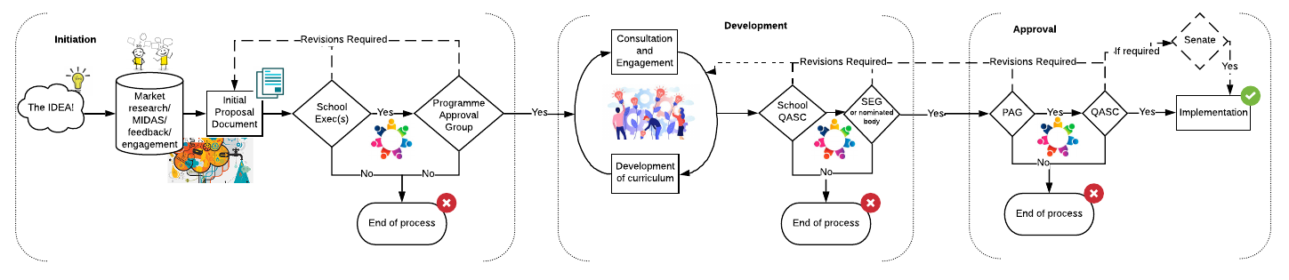

Figure 3: Level 1 Summary Process

  - The most complex and highest risk proposals will be considered using a process that is more robust and rigorous and which provides the opportunity for full engagement with, and consideration of, the proposals. The approach will include an initiation phase, followed by a period of development and consideration within the School and will then come continue to formal approval.
  - As outlined in the Programme Development Framework examples of this kind of proposal include but are not limited to:
    - New programme approval
    - Programme withdrawal
    - Approval of new collaborative programmes/ partnerships
    - Creation of a new category of award (e.g. ProfDoc, MBA, BEng)
    - Development of a new programme model or type (e.g. apprenticeships)
  - Withdrawal or suspension of a programme should be planned well in advance and be part of the School’s strategic and operational planning. This planning will typically be led by the School Programme and Partnership Agreement Development Committee.
    - Unplanned withdrawal of programmes where there are applicants or continuing students who would be unable to complete their intended degree will only be considered under exceptional and unforeseen circumstances. Reference should be made to the Emergency Powers section for more information. Under such exceptional and unforeseen circumstances, formal agreement should be sought from the Vice-Principal (Education) who will liaise with the Directors of Quality and Academic Standards, Legal, Strategic Planning and members of Registry and External Relations, and the relevant Dean(s) in reaching a decision to bring forward a proposal of this nature. Consideration will be given to the potential impact on any continuing students or prospective students and the proposed alternative arrangements for those individuals.

Initiation
  - All proposals will start with the initiation stage which aims to provide a light-touch proposal process that supports effective, swift and transparent decision-making by the School and University at the early stage of the proposal’s development. This will in turn support a School, or the Institution, to identify opportunities and create proposals that focus on market, sustainability and strategic fit and initial due diligence without significant investment of time or resource at this preliminary stage and prior to any significant development being undertaken. The following provides an outline of this stage.
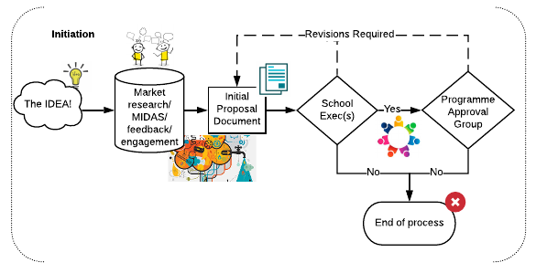
Figure 4: Level 1 Summary Process - Initiation Stage only

  - Ideas may come from a range of sources; it might be that the these are generated through the ongoing activities of colleagues in the School at large, the School Programme and Partnerships Agreement Development Committee (PPADC), External Relations or the PAG as a result of ongoing research, or from student or alumni suggestions as well as emerging trends in enquiries for particular programmes or continued reduction in student enrolment. It is expected that Schools, through the PPADC will consider these ideas in light of the information provided in the Market Intelligence Data Analysis System (MIDAS) and other market intelligence tools and mechanisms to identify if they wish to pursue the opportunity.
  - If the School does wish to consider a proposal beyond the idea stage the SEG will nominate a ‘Responsible Person’ to develop the proposal by gathering relevant information/ data to support decision-making and complete the Initial Proposal Documentation.
  - Appropriate templates and guidance will be provided to the Responsible Person, these will be updated regularly to ensure that completed proposals provide colleagues with the relevant information to support informed decision-making.

School Executive Group
  - The responsible decision-maker within the School at this initial stage is the SEG and the decisions available to them at this stage are:
    - Approve – the proposal will then move to the PAG
    - Not Approved – the proposal will not proceed further
    - Requires revision – the proposal returns to the Responsible Person for revision, with guidance regarding any required changes to be made to support reconsideration of the proposal being provided to them.
  - The outcome of the School’s consideration will be recorded in the minutes of the meeting, and the proposal document and extract of the minute will be submitted to the PAG to ensure a complete record of all proposals considered is maintained. This includes proposals that are not approved; these will not be reconsidered however the outcome will be recorded to support future planning opportunities.
  - The School may provide additional contextual information in support of a proposal at this stage if it wishes to do so, this should be submitted in writing to the PAG alongside the Initial Proposal Document.
  - For those proposals that have received School approval the Initial Proposal Document will be submitted to PAG who is the final decision-maker within the Institution at this initial stage.

Programme Approval Group
  - The Strategic Planning Team will review the documentation submitted prior to consideration by PAG. Where information is missing or incomplete the proposal will be returned to the School and the proposal will be presented to the next available PAG meeting.
  - PAG will consider the information presented against the Institutional Strategy and any relevant annual priorities and existing projects and will confirm if the proposal should proceed to further development at this point. Where the programme involved is a research programme it is expected that PAG consult the Doctoral Academy Board. The decisions available to PAG at this stage are:
    - Approve – the proposal will then move to the next stage
    - Not Approved – the proposal will not proceed further. Where a proposal is not approved the reasons for that decision will be provided to the School to support future development of programme activity.
    - Requires revision – the proposal returns to the School for revision, with guidance regarding any required changes provided.
  - The outcome of the PAG’s consideration will be recorded in the minutes of the meeting, and a complete record of all proposals considered will be maintained and will be communicated to the School and QAS by the Secretary of PAG.
  - Where a proposal is approved at this initial stage the SEG will nominate a ‘Responsible Person’ to lead the proposal’s ongoing development. This may, or may not, be the same individual appointed during the initiation phase and it is for the School to determine who would be most appropriate for this stage. The responsible person will coordinate the development of the full proposal and ensure submission of the relevant documentation to the decision-making groups by gathering relevant information/ data to support decision-making and completing the required documentation.

Development
  - The Development stage provides the opportunity for the full development of the proposal with a range of stakeholders. This should be considered an iterative process, one that embraces evaluation, feedback and development in pursuit of a full and complete proposal that is robust and adequately addresses the needs of the proposal type. The stage is designed to ensure effective and transparent decision-making at this crucial stage of the proposal’s development.
  - The development stage will support the assessment of the sustainability of the proposal and where relevant the development of the curriculum or consideration of the withdrawal of the programme.
  - The full proposal is now developed by the Responsible Person (and team if relevant.) It is also expected that student representatives are involved in this development process.
  - Appropriate templates and guidance will be provided to the Responsible Person, these will be updated regularly to ensure that completed proposals provide colleagues with the relevant information to support informed decision-making.
  - The following summarises this stage:
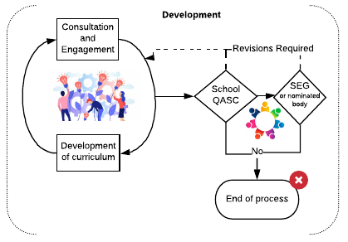
Figure 5: Level 1 Summary Process - Development Stage only

Development of the Proposal
  - For a new programme the full proposal will provide a clear map of the curriculum and proposals will include consideration of key elements such as the marketing and recruitment strategy, sustainability, risks, intended applicants, target numbers and admissions requirements. Where appropriate the proposal will include elements such as the programme aims and learning outcomes, module lists and award title.
  - Where the proposal focuses on the withdrawal of a programme full consideration should be given at this stage as to the implication of the withdrawal including on currently registered/deferred students and other programmes with ties to the curriculum, for example through shared modules. It is important for the proposing team to consider the implications beyond the ‘home’ School.

Sustainability
  - The consideration of a proposal’s sustainability includes the financial viability of the proposal as well as the ongoing relationships with the partner (if applicable), alumni and students. This will include consideration of student numbers and student outcomes as well as the resource and commitment needed for the ongoing support of the proposal. In the case of a programme withdrawal, consideration of the impact of the withdrawal on both the institutions programme portfolio and the ambitions for student growth will be taken into account.
  - Consideration of impact on the existing estate or required capital investment will also be made during the review of a programme’s future sustainability or withdrawal.
  - Consideration of appropriate fee levels will be undertaken where a new programme is being developed.
  - The Responsible Person will be required to consider the implementation planning for the proposal. Where a proposal to withdraw a programme is being made consideration of any ‘teach-out’ requirements should be made at this time.
  - This process will be guided by appropriate resources made available to ensure all relevant information is gathered and considered.

Consultation and Engagement
  - Consultation and engagement with a broad range of stakeholders is a requirement of Level 1 proposals. This ensures that we are able to anticipate and manage challenges as well as develop the strongest proposals possible through the contribution of others.
  - The stakeholders engaged at this point will include students, academic colleagues, staff from across the professional services directorates, external academic and/or industry experts, and others as deemed appropriate by the School, for example partner institutions or organisations such as the NHS.
  - It is anticipated that this element of the process will likely be a combination of informal and formal elements, and should include a consultation and engagement event with a panel made up of the internal and external stakeholders (see below) to support an open dialogue and discussion of the proposals and feedback. (Appendix B)
  - Consultation can also be supported by a range of activities including focus groups, one-to-one meetings, questionnaires, roadshows or other information/consultation events as deemed appropriate to the scale and nature of the proposal.
  - During the selected activities the proposals will be presented to stakeholders who will be asked to review and consider what is being proposed with the goal of providing feedback that supports the further development of the proposal and/or recognition of the weaknesses of the proposal. This is an iterative process and one that is intended to strengthen the proposal and support the development team in creating a proposal that is robust, fully tested and that achieves the goals of the initiation proposal.
  - The outcomes of this consultation should be recorded within the proposal documentation, including a demonstration of how they have contributed to the proposal’s development.
  - The Responsible Person should utilise tools such as the MIDAS, the Module Review Dashboard and the Curriculum Network Dashboard to identify any particular opportunities for engagement and consultation.
  - As a minimum it is expected that Level 1 Consultation and Engagement should involve the following internal stakeholders:
    - An Associate Dean Learning & Teaching from outwith the proposing School
    - An Associate Dean Quality & Academic Standards from outwith the proposing School
    - The module/programme leader of modules/programmes impacted by the proposal (where applicable)
    - A School Manager from outwith the proposing School
    - School President (of the home School) and through them DUSA
    - The QAS Team
    - The Course Operations Group
    - The Library and Learning Centre, including the Centre for Technology and Innovation in Learning (CTIL)
    - Academic Skills Centre
    - Careers Services
    - Others as deemed appropriate by the School based on the scope of the proposal for example;
      - An Associate Dean International from outwith the proposing School
      - An Associate Dean Research from outwith the proposing School
      - Research and Innovation Services
      - The Library and Learning Centre Research Services
      - Global Partnerships (Go Abroad Team)
If the School/Responsible Person is unsure as to who to involve support can be sought from the QAS Team to identify the appropriate group.
  - Following the final development of the proposal as a result of the consultation and engagement process the Responsible Person will submit the relevant documentation to the SQASC.

School Quality & Academic Standards Committee
  - The SQASC will particularly consider the proposal’s curriculum and academic goals, in particular if the proposal is appropriately mapped to the relevant SCQF levels, supports the achievement of the Curriculum Design Principles. The SQASC will also ensure the proposal is fully complete so as to allow implementation of the proposal if approved by the University.
  - The decisions available to SQASC at this stage are:
    - Approve – the proposal is submitted by the Responsible Person to the QASC
    - Not Approved – the proposal will not move forward at this time and the proposal will be withdrawn. Where a proposal is not approved reasons for that decision will be provided to the Responsible Person to support future development of programme activity.
    - Requires revision – the proposal returns to the Responsible Persons with guidance on areas for further development required prior to resubmission to the SQASC.
  - Where a proposal involves more than one School each SQASC should review the proposal and confirm their approval prior to submission to the relevant SEG. If the SQASC’s are unable to agree on the outcome of the consideration the proposal may be submitted to the lead SEG with an accompanying cover paper explaining why a resolution has not be possible.
  - The outcome of the SQASC’s consideration will be recorded in the minutes of the meeting, and a complete record of all proposal’s considered will be maintained and submitted periodically, on request, to the QAS team.

School Executive Group
  - Following approval by the SQASC the Level 1 Proposal will be reconsidered by the SEG who will make the decision to proceed with submission of the proposal to the University for consideration.
  - Where a proposal has not met with approval by the SQASC it cannot be progressed unless it is subsequently revised, resubmitted and receives approval.
  - The SEG will particularly consider the proposal’s strategic fit with the School plans, the business plan, resourcing, implementation plans and budget.
  - The decisions available to SEG at this stage are:
    - Approve – the proposal is submitted by the Responsible Person to the PAG
    - Not Approved – the proposal will not move forward at this time and the proposal will be withdrawn. Where a proposal is not approved reasons for that decision will be provided to the proposing team to support future development of programme activity.
    - Requires revision – the proposal returns to the development team with guidance on areas for further development required prior to resubmission to the SEG for reconsideration
  - Where a proposal involves more than one School each SEG should review the proposal and confirm their approval prior to submission to the PAG. If the School SEG’s are unable to agree on the outcome of the consideration the proposal may be submitted to PAG by the lead School with an accompanying cover paper explaining why a resolution has not be possible.
  - The outcome of the SEG’s consideration will be recorded in the minutes of the meeting, and a complete record of all proposal’s considered will be maintained and will be communicated to QAS and PAG by the secretary of the SEG.

Approval
  - Following development and approval, by the School, the final approval of the proposal is required. The diagram below outlines how this will take place. The Responsible Person will ensure that proposals are submitted to the PAG.
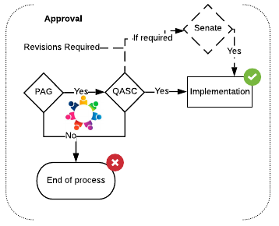
Figure 6: Level 1 Summary Process - Approval Stage only

Programme Approval Group
  - Following consideration by the SEG the Level 1 Proposal will be reconsidered by the PAG who will make the decision to proceed with submission of the proposal to the QASC for consideration.
  - The Strategic Planning Team will review the documentation submitted prior to consideration by PAG. Where information is missing or incomplete the proposal will be returned to the School and the proposal will be presented to the next available PAG meeting.
  - The PAG will particularly consider the proposal’s strategic fit, business plan, resourcing and budget.
  - Either a representative of the Responsible Person, or the School’s Associate Dean QAS may be invited to respond to any questions by the PAG to inform their consideration of the proposal.
  - The decisions available to PAG at this stage are:
    - Approve – the proposal is forwarded, by the School, to the QAS Team for consideration by QASC
    - Not Approved – the proposal will not move forward at this time and the proposal will be withdrawn. Where a proposal is not approved reasons for that decision will be provided to the School to support future development of programme activity.
    - Requires revision – the proposal returns to the School with guidance on areas for further development required prior to resubmission to PAG.
  - The outcome of the PAG’s consideration will be recorded in the minutes of the meeting, and a complete record of all proposal’s considered will be maintained and will be communicated to the School and QAS by the Secretary of PAG. Quality & Academic Standards Committee
  - Following approval of the proposal by the PAG the School will request that it be considered by QASC. Where a School chooses not to take forward the proposal PAG should be notified.
  - The QAS team will review the documentation submitted prior to consideration by QASC. Where information is missing or incomplete the proposal will be returned to the School and the proposal will be presented to the next available QASC meeting. The PAG committee manager will be informed, and consideration given to whether the completed/updated proposal will require reconsideration by PAG prior to QASC.
  - The QASC will particularly consider the proposal’s curriculum and academic goals, considering if the proposal supports the achievement of the Curriculum Design Principles and is fully complete so as to support implementation.
  - Either a representative of the Responsible Person, or the School’s Associate Dean QAS may be invited to respond to any questions by the QASC to inform their consideration of the proposal.
  - The decisions available to QASC at this stage are:
    - Approve – the QAS team will confirm to the School and relevant internal stakeholders of the decision to approve the proposal. The relevant documentation will be updated in the institution’s definitive record of the portfolio and implementation will be able to proceed.
    - Not Approved – the proposal will not move forward at this time and the proposal will be withdrawn. Feedback will be provided to the PAG and the School to inform future proposal developments.
    - Requires revision – the proposal returns to the School with guidance on areas for further development required prior to resubmission to QASC.
  - The outcome of the QASC’s consideration will be recorded in the minutes of the meeting, and a complete record of all proposals considered will be maintained and will be communicated to the School and PAG by the QAS team.
  - Where a proposal includes the development of a new programme model or award designation and the approval of Senate and/or Court is required, the QAS Team will forward the proposal to the Clerk to Senate, on behalf of the School. The Clerk to Senate will then coordinate submission of the appropriate documentation with the School to the next available meeting of Senate and/or Court as required. The responsibility for appropriate recording of the outcome of such decision’s rests with the QAS Team along with the Clerk to Senate.

Implementation
  - Following final approval of the Level 1 proposal implementation may commence.
  - No proposal can be advertised, nor applications opened to it, until the final approval has been confirmed.
  - Communication with applicants, current students and graduates impacted by the proposal must be coordinated by the Responsible Person alongside the relevant colleagues in External Relations.
  - Where the proposal involves co-delivery with a partner all necessary legal agreements must be agreed and signed by all parties prior to the proposal being advertised and applications opened.
  - Where the proposal involves the withdrawal of a programme of study all students should be informed of the decision and the approved teach-out arrangements fully explained to them, along with any options they may wish to consider in relation to their ongoing studies. This includes students who have deferred or suspended their studies at the time of the approval.
  - When the withdrawal of a programme is approved no new students should be admitted to that programme and the application process should be halted immediately.

Review
  - Following implementation of the proposal, where it includes the introduction of a new programme or other curricular element, it will be expected that a regular review is undertaken as outlined below.
  - The curriculum and other academic-related elements of the programme will be considered on an annual basis through the usual module and programme enhancement reviews undertaken by the School.
  - For new programmes it is expected that an interim Periodic Programme Review (PPR) will be undertaken in the third year after the first intake of students. A full PPR will then be undertaken in the sixth year after the first intake of students and then subsequent PPR’s will take place within the usual 6-year regular cycle. For more information about the requirements for a full or interim PPR please refer to the Policy and Guidance for Taught Programmes or the Research Degrees Quality Code.
  - For the first three years, following launch, of a new programme the PAG will consider annually, the programme’s performance, particularly in relation to student enrolment against the approved budget and student enrolment plans. Where the programme does not meet the targets outlined within the approved plans the PAG will review the circumstances of that outcome to identify the root causes and they may subsequently agree that the programme is withdrawn or requires development. Where a programme is to be withdrawn appropriate teach-out arrangements must be made for currently enrolled/deferred students. This decision will be made following consultation with the School and relevant stakeholders. Appropriate guidance will be provided by PAG to Schools to support this oversight and review.
  - Following this three-year period programmes will continue to be reviewed by PAG as part of the groups oversight of the institutional portfolio.

Level 2

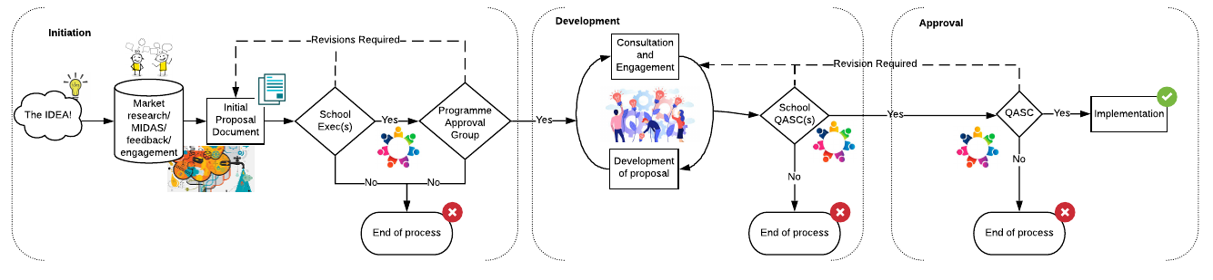
Summary of Approach

Figure 7: Level 2 Summary Process

  - Level 2 proposals are those considered to be high risk but simpler in their goals than those within Level 1. The process will be robust and rigorous and provide the opportunity for full engagement and consideration of the proposals. The approach will include an initiation phase, followed by a period of development and consideration within the School and will then continue to the formal approval.
  - As outlined in the Programme Development Framework Level 2 proposals are those that result in a material impact to a programme for which we award credit or are the awarding body. This will include the addition or withdrawal of programme pathways, or ‘major’ changes to a programme which impacts on the learning outcomes and might materially change the character of the programme. Examples of this kind of proposal include but are not limited to:
    - New programme pathway approval
    - Changes to an existing programmes learning outcomes and/or credit requirement/SCQF Level
    - Changes to the teaching mode (e.g. full-time, part-time) or delivery (e.g. on campus, blended, online)
    - Changes to the title of the award
    - Withdrawal of a programme pathway
    - Withdrawal of a core module that contributes to more than one School’s programmes
    - Degree regulation changes which are not as a consequence of Level 2 or 3 amendments or University Policy changes
    - Addition or removal of entry/exit points.
  - Proposed pathway withdrawals should be approved by the QASC sufficiently in advance of the implementation date so that the University is able to provide accurate public information about its portfolio of programmes and ensure that the relevant programme(s) does not attract new applicants.
  - Unplanned withdrawal of programme pathways where there are applicants or continuing students who would be unable to complete their intended degree will only be considered under exceptional and unforeseen circumstances. Reference should be made to the Emergency Powers section for more information. Under such exceptional and unforeseen circumstances, formal agreement should be sought from the Vice-Principal (Education) who will liaise with the Directors of Quality and Academic Standards, Legal, Strategic Planning and members of Registry and External Relations, and the relevant Dean(s) in reaching a decision to bring forward a proposal of this nature. Consideration will be given to the potential impact on any continuing students or prospective students and the proposed alternative arrangements for those individuals.
  - It is expected that throughout this process colleagues will support effective consultation with all relevant stakeholders, some of whom should be involved during the Initiation phase. This will ensure that all possible support is provided to the proposers and any limiting factors are identified timeously.

Initiation
  - All proposals will start with the initiation stage which aims to provide a light-touch proposal process that supports effective, swift and transparent decision-making by the School and University at the early stage of the proposal’s development. This will in turn support a School, or the Institution, to identify opportunities and create proposals without significant investment of time or resource at this preliminary stage. The following provides an outline of this stage:

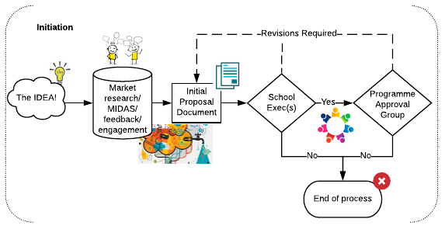

Figure 8: Level 2 Summary Process - Initiation Stage only

  - Ideas may come from a range of sources; it might be that the these are generated through the ongoing activities of colleagues in the School at large, the School Programme and Partnerships Agreement Development Committee (PPADC), External Relations or the PAG as a result of ongoing research, or from student or alumni suggestions as well as emerging trends in enquiries for particular programmes or continued reduction in student enrolment. It is expected that Schools, through the PPADC if applicable at this level, will consider these ideas in light of the information provided in the Market Intelligence Data Analysis System (MIDAS) and other market intelligence tools can and should be used to assess opportunities where MIDAS does not support consideration for example at a module level.
  - If the School does wish to consider a proposal beyond the idea stage the SEG will nominate a ‘Responsible Person’ to develop the proposal by gathering relevant information/ data to support decision-making and complete the Initial Proposal Documentation.
  - Appropriate templates and guidance will be provided to the Responsible Person. These will be updated regularly to ensure that completed proposal’s provide colleagues with the relevant information to support informed decision-making.

School Executive Group
  - The responsible decision-maker within the School at this initial stage is the SEG and the decisions available to them at this stage are:
    - Approve – the proposal will then move to the PAG
    - Not Approved – the proposal will not proceed further
    - Requires revision – the proposal returns to the Responsible Person for revision, with guidance regarding any required changes to be made to support reconsideration of the proposal.
  - The outcome of the School’s consideration will be recorded in the minutes of the meeting, and the proposal document and extract of the minute will be submitted to the PAG to ensure a complete record of all proposal’s considered is maintained.
  - The School may provide additional contextual information in support of the proposal at this stage if it wishes to do so. This should be submitted in writing to the PAG.
  - The SEG will not be required to consider Level 2 proposals a second time. However, if the SEG wish to do so they may and should ensure that this requirement is made clear to the proposing team at the Initiation stage.
  - For those proposal’s that have received School approval the Initial Proposal Document will be submitted to PAG who is the final decision-maker within the Institution at this initial stage.

Programme Approval Group
  - The Strategic Planning Team will review the documentation submitted prior to consideration by PAG. Where information is missing or incomplete the proposal will be returned to the School and the proposal will be presented to the next available PAG meeting.
  - PAG will consider the information presented against the Institutional Strategy and any relevant annual priorities and existing projects and will confirm if the proposal should proceed on to further development at this point. Where the programme involved is a research programme it is expected that PAG consult the Doctoral Academy Board. The decisions available to PAG at this stage are:
    - Approve – the proposal will then move to the next stage
    - Not Approved – the proposal will not proceed further. Where a proposal is not approved reasons for that decision will be provided to the proposing team to support future development of programme activity.
    - Requires revision – the proposal returns to the School for revision, with guidance regarding any required changes provided.
  - The outcome of the PAG’s consideration will be recorded in the minutes of the meeting, and a complete record of all proposal’s considered will be maintained and will be communicated to the School and QAS by the Secretary of PAG.
  - Where a proposal is approved at this initial stage the SEG will nominate a ‘Responsible Person’ to lead the proposal’s ongoing development. This may, or may not, be the same individual appointed during the initiation phase and it is for the School to determine who would be most appropriate for this stage. The responsible person will coordinate the development of the full proposal and ensure submission of the relevant documentation to the decision-making groups by gathering relevant information/ data to support decision-making and completing the required documentation.

Development
  - The Development stage provides the opportunity for the full development of the proposal with a range of stakeholders. This should be considered an iterative process, one that embraces evaluation, feedback and development in pursuit of a full and complete proposal that is robust and adequately addresses the needs of the proposal type. The stage is designed to ensure effective and transparent decision-making at this crucial stage of the proposal’s development.
  - The development stage will support the assessment of the sustainability of the proposal and where relevant the development of the proposal or consideration of the withdrawal of the pathway.
  - The full proposal is now developed by the Responsible Person (and team if relevant). It is also expected that student representatives are involved in this development process.
  - Appropriate templates and guidance will be provided to the Responsible Person, these will be updated regularly to ensure that completed proposals provide colleagues with the relevant information to support informed decision-making.
  - The following summarises this stage:
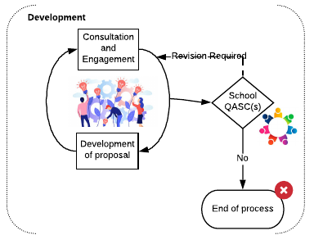
Figure 9: Level 2 Summary Process - Development Stage only

Development of the Proposal
  - The full proposal is now developed by the Responsible Person.
  - The full proposal will provide a clear map of the curriculum in relation to the proposal. It will consider key elements such as the marketing and recruitment strategy, sustainability and any identified risks. The proposal will include elements such as the learning outcomes, modules and the proposed amendments, implications for assessment and student experience.
  - Where the proposal focuses on the withdrawal of a pathway full consideration should be given at this stage as to the implication of the withdrawal including on currently registered/deferred students and other programmes/pathways with ties to the curriculum, for example through shared modules. It is important for the proposing team to consider the implications beyond the ‘home’ School.

Sustainability
  - The consideration of a proposal’s sustainability includes the financial viability of the proposal as well as the ongoing relationships with the partner (if applicable), alumni and students. This will include consideration of student numbers and student outcomes as well as the resource and commitment needed for the ongoing support of the proposal. In the case of a pathway withdrawal consideration of the impact of the withdrawal on both the institution’s programme portfolio and the ambitions for student growth will be taken into account.
  - Consideration of impact on the existing estate or required capital investment will also be considered during the review of a programme’s future sustainability or withdrawal.
  - Consideration of appropriate fee levels will be undertaken where a new pathway is being developed.
  - The Responsible Person will be required to consider the implementation planning for the proposal. Where a proposal to withdraw a pathway is being made consideration of any ‘teach-out’ requirements should be made at this time.
  - This process will be guided by appropriate resources made available to ensure all relevant information is gathered and considered.

Consultation and Engagement
  - Consultation and engagement with a broad range of stakeholders is a requirement of Level 2 proposals. This ensures that we are able to anticipate and manage challenges as well as develop the strongest proposal’s possible through the contribution of others.
  - The stakeholders engaged at this point will include students, academic colleagues, staff from across the professional services directorates, external academic and/or industry experts, and others as deemed appropriate by the School, for example partner institutions or organisations such as the NHS.
  - It is anticipated that this element of the process will likely be a combination of informal and formal elements, and this can include a consultation and engagement event, to support an open dialogue and discussion of the proposal and feedback. The Responsible Person should agree the approach to be taken to consultation and engagement with the relevant Associate Dean QAS.
  - Consultation can be supported by a range of activities including focus groups, one-to-one meetings, questionnaires, roadshows or other information/consultation events as deemed appropriate to the scale and nature of the proposal.
  - During the chosen activities the proposal’s will be presented to stakeholders who will be asked to review and consider what is being proposed with the goal of providing feedback that supports the further development of the proposal and/or recognition of the weaknesses of the proposal. This is an iterative process and one that is intended to strengthen the proposal and support the development team in creating a proposal that is robust, fully tested and that achieves the goals of the initiation proposal.
  - The approach agreed and taken should be documented within the proposal along with the outcomes, including a demonstration of how they have contributed to the proposal’s development.
  - The Responsible Person can use tools such as the Module Review Dashboard and the Curriculum Network Dashboard to identify any particular opportunities for engagement and consultation.
  - As a minimum it is expected that Level 2 Consultation and Engagement should involve the following internal stakeholders:
    - An Associate Dean Learning & Teaching from outwith the proposing School
    - An Associate Dean Quality & Academic Standards from outwith the proposing School
    - The module/programme leader of modules/programmes impacted by the proposal (where applicable)
    - School President (of the home School) and through them DUSA and students
    - The QAS Team
    - The Course Operations Group
    - The Library and Learning Centre, including the Centre for Technology and Innovation in Learning (CTIL)
    - Others as deemed appropriate by the School based on the scope of the proposal for example;
      - A School Manager from outwith the proposing School
      - An Associate Dean International from outwith the proposing School
      - An Associate Dean Research from outwith the proposing School
      - Research and Innovation Services
      - The Library and Learning Centre Research Services
      - Academic Skills Centre
      - Careers Services
      - Global Partnerships (Go Abroad Team)
If the School/Responsible Person is unsure as to who to involve support can be sought from the QAS Team to identify the appropriate group.

School Quality & Academic Standards Committee
  - Following the final development of the proposal as a result of the consultation and engagement process the Responsible Person will submit the relevant documentation to the School Quality and Academic Standards Committee.
  - The School QAS team will review the documentation submitted prior to consideration by SQASC. Where information is missing or incomplete the proposal will be returned to the Responsible Person and the proposal will be presented to the next available SQASC meeting.
  - The SQASC will particularly consider the proposal’s curriculum and academic goals, considering if the proposal is appropriately mapped to the relevant SCQF levels, supports the achievement of the Curriculum Design Principles and is fully complete so as to allow implementation of the proposal if approved by the University.
  - The decisions available to SQASC at this stage are:
    - Approve – the proposal is submitted by the Responsible Person to the QASC
    - Not Approved – the proposal will not move forward at this time and the proposal will be withdrawn. Where a proposal is not approved reasons for that decision will be provided to the proposing team to support future development of programme activity.
    - Requires revision – the proposal returns to the Responsible Person with guidance on areas for further development required prior to resubmission.
  - The outcome of the SQASC’s consideration will be recorded in the minutes of the meeting, and a complete record of all proposals considered will be maintained and will be communicated to the proposing team by the Secretary of the SQASC. Approval
  - Following development and approval, by the School, of the proposals, the final approval of the proposal is required, the diagram below outlines how this will take place. The Responsible Person will ensure that proposals are submitted to the PAG.
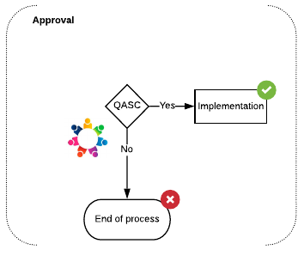
Figure 10: Level 2 Summary Process - Approval Stage only

Quality & Academic Standards Committee
  - Following approval of the proposal by the SQASC the proposal will be forwarded to the QAS Team for consideration by QASC.
  - The QAS team will review the documentation submitted prior to consideration by QASC. Where information is missing or incomplete the proposal will be returned to the School and the proposal will be presented to the next available QASC meeting.
  - The QASC will particularly consider the proposal’s curriculum and academic goals, considering in particular if the proposal supports the achievement of the Curriculum Design Principles and is fully complete so as to support implementation.
  - Either the Responsible Person or nominated representative, or the School’s Associate Dean QAS may be invited to respond to any questions by the QASC to inform their consideration of the proposal.
  - The decisions available to QASC at this stage are:
    - Approve – the QAS team will confirm to the School and relevant internal stakeholders the decision to approve the proposal. The relevant documentation will be added to the institution’s definitive record of the portfolio and implementation will be able to proceed.
    - Not Approved – the proposal will not move forward at this time and the proposal will be withdrawn. Feedback will be provided to the PAG and the School to inform future proposal developments.
    - Requires revision – the proposal returns to the School with guidance on areas for further development required prior to resubmission.

Implementation
  - No proposal can be advertised, nor applications opened to it, until the final approval has been confirmed.
  - Communication with applicants, current students and graduates impacted by the proposal must be coordinated by the Responsible Person alongside the relevant colleagues in External Relations.
  - Where the proposal involves co-delivery with a partner all necessary legal agreements must be agreed and signed by all parties prior to the proposal being advertised and applications opened.
  - Where the proposal involves the withdrawal of a programme pathway-of study all students should be informed of the decision and the approved teach-out arrangements fully explained to them, along with any options they may wish to consider in relation to their ongoing studies. This includes students who have deferred or suspended their studies at the time of the approval.
  - When the withdrawal of a programme pathway is approved no new students should be admitted to that programme pathway and the application process should be halted immediately.

Review
  - Following implementation of the proposal, where it includes the introduction of a new pathway it will be expected that a regular review is undertaken as outlined below.
  - The curriculum and other academic-related elements of the pathway will be considered on an annual basis through the usual module and programme enhancement reviews undertaken by the School.
  - For new pathways it is expected that the pathway will be considered at the next Periodic Programme Review (PPR) of the ‘parent’ programme regardless of where in the 6-year cycle of reviews that programme is placed. For more information about the requirements for PPR please refer to the Policy and Guidance for Taught Programmes or the Research Degrees Quality Code.
  - For the first three years, following launch, of a new pathway the PAG will consider annually, the pathway’s performance, particularly in relation to student enrolment against the approved budget and student enrolment plans. Where the pathway does not meet the targets outlined within the approved plans the PAG may agree that the pathway is withdrawn, with appropriate teach-out arrangements being made for currently enrolled/deferred students. This decision will be made following consultation with the School and relevant stakeholders. Appropriate guidance will be provided by PAG to Schools to support this oversight and review.
  - Following this three-year period pathways will continue to be reviewed by PAG as part of the groups oversight of the institutional portfolio.

Level 3

Summary of Approach

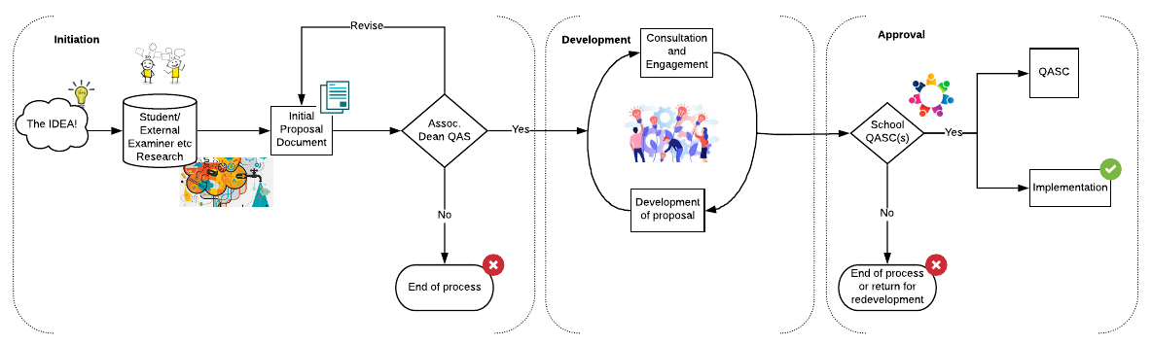

Figure 11: Level 3 Summary Approval Process

  - Level 3 proposals are those considered to be medium-risk proposals. The process will be robust and rigorous and provide the opportunity for full engagement and consideration of the proposals. The approach will include an initiation phase, followed by a period of development, consideration and approval within the School. Level 3 proposals will then be reported to the University.
  - As outlined in the Programme Development Framework Level 3 proposals are those where we award credit at the module level, or where we are amending existing module provision. They will also include ‘minor’ programme amendments that do not impact the overarching curriculum or change the character of the programme. Examples of this kind of proposal include but are not limited to:
    - approval of a new module (core or optional)
    - changes to module learning outcomes or assessments (that do not impact the programme learning outcomes)
    - re-sequencing of previously approved modules within a programme or pathway(s)
    - module withdrawal (one School only)
    - changes to credit rating
    - changes to prerequisites, co-requisites or anti-requisites;
    - changes to the mode of teaching or assessment (for example, use of the VLE or online assessment)
  - Proposed module withdrawals should be approved by the SQASC sufficiently in advance of the implementation date so that the University is able to provide accurate public information about its portfolio of programmes and to support activities such as timetabling.
  - Unplanned withdrawal of modules on which students are enrolled or that have been selected by students as an option within their programme can only be considered under exceptional and unforeseen circumstances. Reference should be made to the Emergency Powers section for more information. Under such exceptional and unforeseen circumstances, formal agreement should be sought from the QAS team who will liaise with the Directors of Quality and Academic Standards, Legal, Strategic Planning and members of Registry and External Relations, as required in reaching a decision to bring forward a proposal of this nature. Consideration will be given to the potential impact on students and the proposed alternative arrangements for those individuals.
  - It is expected that throughout this process colleagues will support effective consultation with all relevant stakeholders, some of whom should be involved during the Initiation phase. This will ensure that all possible support is provided to the proposers and any limiting factors are identified timeously.

Initiation
  - All proposals will start with the initiation stage which aims to provide a light-touch proposal process that supports effective, swift and transparent decision-making by the School at the early stage of the proposal’s development. This will in turn support a School to identify opportunities and create proposals without significant investment of time or resource at this preliminary stage. The following provides an outline of this stage.
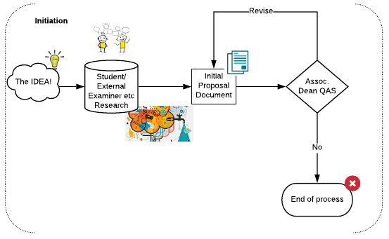
Figure 12: Level 3 Summary Process - Initiation Stage only
  - Ideas may come from a range of sources; it might be that the these are generated through the ongoing activities of colleagues in the School as a result of ongoing research, or from students, alumni or external examiners. Ideas may also be generated through the annual planning, review and enhancement processes.
  - It is for the Schools to decide how they might wish to ‘filter’ proposals at this stage, if at all. Some may wish to channel these initial discussions through Learning and Teaching or Internationalisation Committees or similar, or via individual post-holders.
  - If the School does wish to consider a proposal beyond the idea stage the Associate Dean Quality & Academic Standards will nominate a ‘Responsible Person’ to develop the proposal by gathering relevant information/ data to support decision-making and complete the Initial Proposal Documentation. This person will likely be the current Programme or Module Leader.
  - The Initial Proposal Document will request all the relevant information that the School will need to reach a decision on the proposal.
  - The responsible decision-maker within the School at this initial stage is the Associate Dean Quality & Academic Standards and the decisions available to them at this stage are:
    - Approve – the proposal will then move to the development phase
    - Not Approved – the proposal will not proceed further
    - Requires revision – the proposal returns to the Responsible Person for revision, with guidance regarding any required changes to be made to support reconsideration of the proposal.
  - The outcome of the Associate Dean’s consideration will be recorded, and the proposal document and outcome will be noted at the next SQASC meeting so that a record of all proposals considered is maintained.
  - Where a proposal is approved at this initial stage the Associate Dean Quality & Academic Standards will nominate a ‘Responsible Person’ to lead the proposal’s ongoing development. This may, or may not, be the same individual appointed during the initiation phase. The responsible person will coordinate the development of the full proposal and ensure submission of the relevant documentation to the decision-making groups by gathering relevant information/ data to support decision-making and completing the required documentation.
  - The Programme Development Proposal will request all the relevant information that will be needed to reach a decision on the proposal.

Development
  - The Development stage aims to provide the opportunity for the development of the proposal with a range of stakeholders. This should be considered an iterative process, one that embraces evaluation, feedback and development in pursuit of a full and complete proposal that is robust and adequately addresses the needs of the proposal type. The development stage will support the assessment of the sustainability of the proposal and development of the curriculum or consideration of the withdrawal of the module. The stage is designed to ensure effective and transparent decision-making at this crucial stage of the proposal’s development.
  - Appropriate templates and guidance will be provided to the Responsible Person. These will be updated regularly to ensure that proposals made provide colleagues with the relevant information to support informed decision-making.

Development of the Proposal
  - It is expected that student representatives are involved in this development process.
  - The full proposal documentation will provide a clear outline of the proposal including elements such as the impact on module learning outcomes and/or assessment and implications for the student experience.
  - Where the proposal focuses on the withdrawal of a module full consideration should be given at this stage as to the implication of the withdrawal including on currently registered/deferred students and other programmes/pathways with ties to the curriculum, for example where the module is shared.

Sustainability
  - The aim of the consideration of a proposal’s sustainability includes the financial implications of the proposal as well as resource and commitment for the ongoing support of the proposal. In the case of a module withdrawal it will consider the impact of the withdrawal on the curriculum of any impacted programmes.
  - The Responsible Person will be required to consider the implementation planning for the proposal.

Consultation and Engagement
  - Consultation and engagement with a broad range of stakeholders is a requirement of Level 3 proposals. This ensures that we are able to anticipate and manage challenges as well as develop the strongest proposals possible through the contribution of others.
  - The stakeholders engaged at this point may include students, academic colleagues, staff from across the professional services directorates, external academic and/or industry experts, and others as deemed appropriate by the School, for example partner institutions or organisations such as the NHS.
  - It is anticipated that this element of the process will likely be a combination of informal and formal elements selected to support an open dialogue and discussion of the proposals and feedback. The Responsible Person should agree the approach to be taken to consultation and engagement with the relevant Associate Dean QAS.
  - Consultation can be supported by a range of activities including focus groups, one-to-one meetings, questionnaires, roadshows or other information/consultation events as deemed appropriate to the scale and nature of the proposal.
  - During the chosen activities the proposals will be presented to stakeholders who will be asked to review and consider what is being proposed with the goal of providing feedback that supports the further development of the proposal and/or recognition of the weaknesses of the proposal. This is an iterative process and one that is intended to strengthen the proposal and support the development team in creating a proposal that is robust, fully tested and that achieves the goals of the initiation proposal.
  - The approach agreed and taken should be documented within the proposal along with the outcomes, including a demonstration of how they have contributed to the proposal’s development.
  - The Responsible Person can use tools such as the Module Review Dashboard and the Curriculum Network Dashboard to identify any particular opportunities for engagement and consultation.
  - As a minimum it is expected that Level 3 Consultation and Engagement should involve the following internal stakeholders:
    - An academic from outwith the proposing School
    - The module/programme leader of modules/programmes impacted by the proposal
    - School Vice-President (of the home School) and through them DUSA and students
    - The QAS Team
    - The Course Operations Group
    - The Library and Learning Centre, including the Centre for Technology and Innovation in Learning (CTIL)
    - Others as deemed appropriate by the School based on the scope of the proposal for example;
      - An Administrative Lead for QAS or Learning & Teaching from outwith the proposing School
      - An Associate Dean International from outwith the proposing School
      - An Associate Dean Research from outwith the proposing School
      - Research and Innovation Services
      - The Library and Learning Centre Research Services
      - Academic Skills Centre
      - Careers Services
      - Global Partnerships (Go Abroad Team)
If the School/Responsible Person is unsure as to who to involve support can be sought from the QAS Team to identify the appropriate group.

Approval
  - Following development of the proposals, the final approval of the proposal is required, the diagram below outlines how this will take place. The Responsible Person will ensure that proposals are submitted to the SQASC.
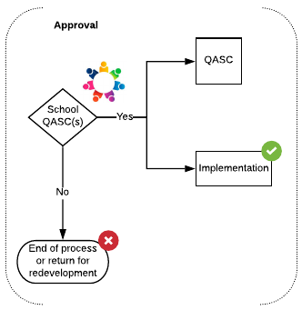
Figure 13: Level 3 Summary Process - Approval Stage Only

School Quality & Academic Standards Committee
  - Following the final development of the proposal as a result of the consultation and engagement process the Responsible Person will submit the relevant documentation to the School Quality and Academic Standards Committee.
  - The School QAS team will review the documentation submitted prior to consideration by SQASC. Where information is missing or incomplete the proposal will be returned to the School and the proposal will be presented to the next available SQASC meeting.
  - The SQASC will particularly consider the proposal’s curriculum and academic goals, considering in particular if the proposal supports the achievement of the Curriculum Design Principles and is fully complete so as to support implementation.
  - The Responsible Person may be invited to respond to any questions by the SQASC to inform their consideration of the proposal.
  - The decisions available to SQASC at this stage are:
    - Approve – the proposal is submitted to QAS for recording within the definitive record of the portfolio
    - Not Approved – the proposal will not move forward at this time and the proposal will be withdrawn. Where a proposal is not approved reasons for that decision will be provided to the proposing team to support future development of programme activity.
    - Requires revision – the proposal returns to the development team with guidance on areas for further development required prior to resubmission.
  - The outcome of the SQASC’s consideration will be recorded in the minutes of the meeting, and a complete record of all proposals considered will be maintained and will be communicated to the proposing team by the Secretary of the SQASC.

Implementation
  - Following approval of the Level 3 proposal by the School implementation may commence.
  - Where the proposal involves the withdrawal of a module all students should be informed of the decision and the approved alternatives fully explained to them (where applicable.) This includes students who have deferred or suspended their studies at the time of the approval.

Quality & Academic Standards Committee
  - Following approval of the proposal by the SQASC the proposal will be forwarded to the QAS Team for noting by QASC.
  - The QAS team will review the documentation submitted. Where information is missing or incomplete the proposal will be returned to the School and implementation must be paused until this is resolved.

Review
  - Following implementation of the proposal, and particularly where it includes the introduction of a new module regular review should be undertaken.
  - The curriculum and other academic-related elements of the module will be considered on an annual basis through the usual module and programme enhancement reviews undertaken by the School.

Level 4

Summary of Approach

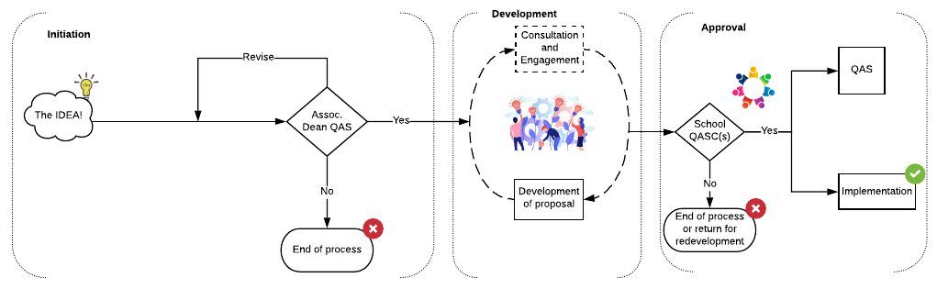

Figure 14: Level 4 Summary Approval Process
  - Level 4 proposals will be those considered to be low-risk proposals. The process will be robust and rigorous and provide the opportunity for full engagement and consideration of the proposals. The approach will include an initiation phase, followed by a period of development, consideration and approval within the School. Level 4 proposals will then be reported to the University.
  - As outlined in the Programme Development Framework Level 4 proposals are those where we do not award credit, or where we are making minor changes to existing provision. Examples of this kind of proposal include but are not limited to:
    - Approval of a non-credit-bearing modules
    - Amendment of non-credit-bearing modules
    - updates to reference points for academic standards (where those do not impact on intended learning outcomes)
    - minor amendments to credit-bearing modules that do not impact module learning outcomes or assessment e.g. slight changes to the balance of teaching modes
    - changes to the module title (e.g. adding sub-clause to original title)
  - It is expected that throughout this process colleagues will support effective consultation with all relevant stakeholders, some of whom should be involved during the Initiation phase. This will ensure that all possible support is provided to the proposers and any limiting factors are identified timeously.

Initiation
  - Proposals will start with the initiation stage which aims to provide a light-touch proposal process that supports effective, swift and transparent decision-making by the School at the early stage of the proposal’s development. This will in turn support a School to identify opportunities and create proposals without significant investment of time or resource at this preliminary stage.
  - Ideas may come from a range of sources; it might be that the these are generated through the ongoing activities of colleagues in the School as a result of ongoing research, or from students, alumni or external examiners. Ideas may also be generated through the annual planning, review and enhancement processes.
  - It is for the Schools to decide how they might wish to ‘filter’ proposals at this stage, if at all. Some may wish to channel these initial discussions through Learning and Teaching or Internationalisation Committees or similar, or via individual post-holders.
  - If the School does wish to consider a proposal beyond the idea stage the Assoc. Dean Quality & Academic Standards will nominate a ‘Responsible Person’ to develop the proposal by gathering relevant information/ data to support decision-making and complete the Initial Proposal Documentation. This person will likely be the current Programme or Module Leader.
  - The Initial Proposal Document will request all the relevant information that the School will need to reach a decision on the proposal.
  - The responsible decision-maker within the School at this initial stage is the Associate Dean Quality & Academic Standards, and the decisions available to them at this stage are:
    - Approve – the proposal will then move to the development phase
    - Not Approved – the proposal will not proceed further
    - Requires revision – the proposal returns to the Responsible Person for revision, with guidance regarding any required changes to be made to support reconsideration of the proposal.
  - The outcome of the Associate Dean’s consideration will be recorded, and the proposal document and outcome will be noted at the next SQASC meeting so that a record of all proposals considered is maintained.
  - Where a proposal is approved at this initial stage the Associate Dean Quality & Academic Standards will nominate a ‘Responsible Person’ to lead the proposal’s ongoing development. This may, or may not, be the same individual appointed during the initiation phase. The responsible person will coordinate the development of the full proposal and ensure submission of the relevant documentation to the decision-making groups by gathering relevant information/ data to support decision-making and completing the required documentation.
  - The Programme Development Proposal will request all the relevant information that will be needed to reach a decision on the proposal.

Development
  - The Development stage aims to provide the opportunity for the development of the proposal with a range of stakeholders. This should be considered an iterative process, one that embraces evaluation, feedback and development in pursuit of a full and complete proposal that is robust and adequately addresses the needs of the proposal type. The stage is designed to ensure effective and transparent decision-making at this crucial stage of the proposal’s development.
  - Appropriate templates and guidance will be provided to the Responsible Person. These will be updated regularly to ensure that proposals made provide colleagues with the relevant information to support informed decision-making. Sustainability
  - The Responsible Person will be required to consider the implementation planning for the proposal.
  - The full proposal will provide a clear outline of the proposal include elements such as the impact on module learning outcomes and/or assessment and implications for the student experience where this is applicable.

Consultation and Engagement
  - The consultation process should be proportionate, and the Associate Dean (Quality and Academic Standards) should exercise discretion on how the consultation should be undertaken.
  - Consultation and engagement with relevant stakeholders, including students, may be necessary at Level 4 where proposals impact more than one School or programme.
  - The stakeholders engaged at this point may include staff from across the professional services directorates, and others as deemed appropriate by the School, for example partner institutions or organisations such as the NHS.
  - The outcomes of this consultation (where it is deemed necessary) should be recorded within the proposal documentation, including a demonstration of how they have contributed to the proposal’s development.

Approval
  - Following development of the proposals, the final approval of the proposal is required. The diagram below outlines how this will take place. The Responsible Person will ensure that proposals are submitted to the SQASC.
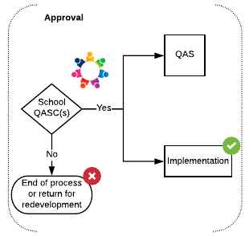
Figure 15: Level 4 Summary Approval Process - Approval Stage only

School Quality & Academic Standards Committee
  - Following the final development of the proposal as a result of the consultation and engagement process the Responsible Person will submit the relevant documentation to the School Quality and Academic Standards Committee.
  - The School QAS team will review the documentation submitted prior to consideration by SQASC. Where information is missing or incomplete the proposal will be returned to the Responsible Person and the proposal will be presented to the next available SQASC meeting.
  - The SQASC will particularly consider the proposal’s curriculum and academic goals, supports the achievement of the Curriculum Design Principles and is fully complete so as to allow implementation of the proposal if approved by the University.
  - The decisions available to SQASC at this stage are:
    - Approve – the proposal is submitted by the Responsible Person to the QAS team
    - Not Approved – the proposal will not move forward at this time and the proposal will be withdrawn. Where a proposal is not approved reasons for that decision will be provided to the proposing team to support future development of programme activity.
    - Requires revision – the proposal returns to the Responsible Person with guidance on areas for further development required prior to resubmission.
  - The outcome of the SQASC’s consideration will be recorded in the minutes of the meeting, and a complete record of all proposals considered will be maintained and will be communicated to the proposing team by the Secretary of the SQASC.

Implementation
  - Following final approval of the Level 4 proposal by the School implementation may commence.

Quality & Academic Standards Team
  - Following approval of the proposal by the SQASC the proposal will be forwarded to the QAS Team for noting by QASC.
  - The QAS team will review the documentation submitted. Where information is missing or incomplete the proposal will be returned to the School and implementation must be paused until this is resolved. The proposal will be presented to the next available QASC meeting.

Level 5

Summary of Approach
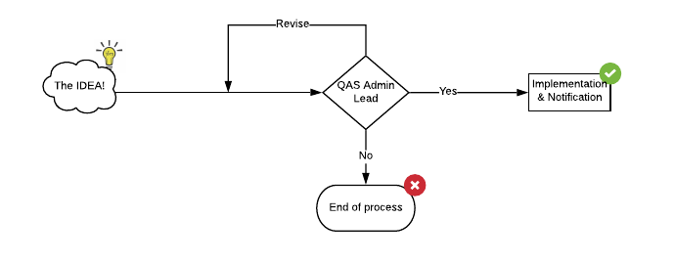
Figure 16: Level 5 Summary Approval Process
  - Level 5 proposals are administrative in nature.
  - As outlined in the Programme Development Framework Level 5 proposals are those where we are making administrative changes to existing provision. Examples of this kind of proposal include but are not limited to:
    - Update of module leader or administrator details
    - Changes to JACS, HECOS, UCAS codes
    - changes to spelling or grammar
    - minor changes to the module title (e.g. grammar update)
    - coding changes
    - changes to names of contacts
    - updates to links to further information
  - The Programme or Module Leader will be the person responsible for preparing the proposal.
  - The Initial Proposal Document will request all the relevant information that the School will need to reach a decision on the proposal.
  - The responsible decision-maker within the School at this initial stage is the Administrative Lead for QAS and the decisions available to them at this stage are:
    - Approve – the proposal will then move to implementation
    - Not Approved – the proposal will not proceed further
    - Requires revision – the proposal returns to the Responsible Person for revision, with guidance regarding any required changes to be made to support reconsideration of the proposal.
  - The outcome of the Administrative Lead’s consideration will be recorded, and the proposal document and outcome will be noted at the next SQASC meeting so that a record of all proposals considered is maintained.

Implementation
  - Following final approval of the Level 4 proposal by the School implementation may commence.

Quality & Academic Standards Team
  - Following approval of the proposal by the School the proposal will be reported to the QAS Team.
  - The QAS team will review the documentation submitted. Where information is missing or incomplete the proposal will be returned to the School and implementation must be paused until this is resolved.

Emergency Powers
  - The University’s Emergency Powers Procedure covers the situation where changes need to be made outwith the normal reporting process and/or timeframe. Emergency powers should only be used under exceptional circumstances. A note of explanation should be provided with the documentation submitted to the Quality and Academic Standards Office.
  - Where Emergency Powers are being used, the University Emergency Powers pro forma must be completed and signed by all relevant parties. The QAS team will ensure that decisions made through Emergency Powers are communicated to the relevant School office, Registry and External Relations and appropriate notification to QASC is undertaken.
  - Staff should consult the 'normal' procedures for relevant level of the Programme Development Framework with the aim of ensuring that as much as possible of these processes are captured in the use of emergency powers.
    - For new programmes, relevant documentation must have been produced with the involvement of External Relations to ensure appropriate launch and marketing activities are possible.
    - For new modules and changes to programmes and modules the COG should be kept informed of developments as soon as possible so they can make administrative changes in good time
  - All documentation must be approved by the Dean and the Associate Dean (Quality and Academic Standards).
  - The Quality & Academic Standards Officer (Programmes and Partnerships) or Director of Quality & Academic Standards must confirm that the relevant documentation has been completed satisfactorily prior to consideration for approval.
  - Thereafter, approval in lieu of Senate will be confirmed by the Vice-Principal (Education).
  - From that point forward it is possible for External Relations to make offers to prospective students for new programmes and for revised programme and/or module specifications to be included in relevant databases.
  - The appropriate documentation should be submitted to the SQASC and approvals conformed retrospectively by the Quality and Academic Standards Committee.

Further information

Double Counting of Credit
  - Occasionally a partner organisation will wish to recognise the credit obtained from the degree awarded by the University of Dundee as part of its own award, essentially meaning that students could receive two certificates for the same credits.
  - Under such circumstances it should be made clear on the student transcripts from both institutions that the award has been made on the basis of recognising the credit from the partner institution, and that the credit is contributing to another award from that partner institution. The transcript from the University of Dundee will state that the credit awarded by the University of Dundee for the specific named award from the University of Dundee is also being recognised by the named partner institution as contributing to the specific named award of the partner institution for that individual student.
  - For certain postgraduate articulation arrangements, students will complete a one-year Master’s degree (a minimum of 180 credits) at the University of Dundee and use the credit to count towards a two-year Masters degree at an overseas institution. Under such circumstances, the articulation agreement should contain an obligation for the partner institution to provide a statement on their student transcript that the Masters degree from the University of Dundee has been recognised as credit that has contributed to the award made by the overseas institution.

External Examiner(s) and Board of Examiners
  - At least one external examiner for a programme must be appointed by the University in accordance with the University’s Policy and Code of Practice on External Examining of Taught Programmes.
  - The appointment of external examiners for research programmes and their roles and responsibilities should be undertaken in accordance with the University’s Research Degree Quality Code

Programme Boards
  - In addition to the Board of Examiners, a Programme Board should be established for each award, or a cognate group of awards, as determined by the Associate Dean QAS. The Programme Board will have oversight of the operation of the programme including all areas relating to quality and academic standards. Virtual meetings may be used where appropriate.

Professional, Regulatory and Statutory Bodies
  - For programmes that have professional accreditation associated with the named degree, a key consideration is whether the programme meets the requirements of the relevant professional, statutory and regulatory body (PSRB). It is of critical importance that the status of a degree in respect of PSRB accreditation is represented accurately so that applicants or students are not misled. A definitive ruling on this must be secured from the relevant PSRB. It is the responsibility of the Responsible Person to seek clarity on the status of PSRB accreditation and ensure that public and internal information about the collaborative programme accurately reflects its accreditation status.

Non-credit-bearing Provision

Certificates of attendance
  - The standard University format for certificates of attendance will include the following information: course title; duration; dates of attendance; the responsible School or Directorate; and date. These certificates should be signed by the Dean of the lead School or Head of the lead Directorate.

Certificates of performance
  - Where certificates of performance are delivered by a Directorate, a School should be appointed to take primary responsibility for quality assurance.
  - In the case of degree programmes where discrete modules or units within modules are available to candidates on a non-graduating basis or as part of continuing professional development, assessment methods should be equivalent to those used for graduating students. This is important as successful completion of such courses has the potential to be included in claims for recognition of prior learning.
  - The standard format for certificates of performance should include the following information: course title; duration; dates of attendance; type of assessment; mode of study; responsible School or Directorate; grade achieved; and date of successful completion. The certificates should be signed by the Dean of the lead School. The format for Open Badges is under development.

Raising a Concern, Whistleblowing and other relevant policies
  - Where a member of staff identifies a concern about a programme relating to the delivery, management, sustainability, quality assurance or student experience these should be raised in the first instance to the Responsible Person for the programme/module/partnership/other. Where the Responsible Person is the subject of the concern, the matter can be raised with the QAS Team or the SEG.
  - Where it is believed that this policy and guidance is being wilfully or recklessly undermined or subverted a disclosure can be made via the University of Dundee Whistleblowing Policy.
  - The University makes an annual statement which outlines the steps taken to ensure slavery and human trafficking are not taking place within the organisation or in any of its supply chains. The Modern Slavery Statement.
  - The University of Dundee’s policy is to conduct business in an honest and ethical manner, consistent with the University values and the nine Principles of Public Life in Scotland, this aim is set out in the Anti-bribery policy.

Document Information

Document Name | Programme Development Policy and Guidance
Status  Responsible officer/department/school  Policy owner  Date last approved  Due for renewal  Information classification: public/internal  Approval route and history | Final  Academic and Corporate Governance  Quality & Academic Standards  26 May 2021  26 May 2023  Public  Doctoral Academy Board 29 April 2021  Programme Approval Group (PAG) 30 April 2021  Quality & Academic Standards Committee (QASC) 5 May 2021  University Executive Group 19 May 2021  Learning & Teaching Committee 11 May 2021  Senate 26 May 2021
Code | PDPG_v001

Glossary

Certificate of Attendance
Courses which attract a certificate of attendance will normally be short courses of a vocational nature and will not include any measure of performance or formal assessment procedures.

Certificate of Performance
Courses which attract a certificate of performance will normally be short courses that may be made up of part or all of an approved module. They will include measurement of performance/formal assessment.

Credit
A means of quantifying and recognising the volume of learning, based on academic judgement as to how long it will take the typical learner to achieve the learning outcomes. The estimation of the time required is referred to as ‘notional learning hours’. One credit point represents a notional 10 hours of learning.

Course
The term ‘course’ is often used interchangeably with either programme or module. Course is typically used during the admissions stages to mean a programme of study and aligns with the language used by UCAS and others.

Core Module
A module that must be successfully passed in pursuit of a programme of study

Option Module
A module that can be chosen by a student to contribute to their programme of study, typically students are provided with a range of option modules to choose from. The number of option modules available will be dependent on the credit and discipline requirements of the programme

MOOC
MOOCs are freely available open online courses provided by the University through platforms including FutureLearn.

Micro-credentials
Micro-credentials offer an opportunity to formally recognise professional development and are typically offered on a credit-bearing basis, aligned to the Scottish Credit & Qualifications Framework. They are subject to standard quality assurance and enhancement mechanisms. There are currently no upper, or lower, limits to the amount of credit that can be awarded for a micro-credential however it is generally accepted that it will not normally constitute an award in its own right.

Non-credit-bearing
The University provides a variety of courses and training opportunities that are not credit-bearing (i.e. they have not been benchmarked against the Scottish Credit and Qualifications Framework (SCQF) and do not formally contribute to an award as described within The Framework for Qualifications of Higher Education Institutions in Scotland).

Non-credit-bearing certificates
‘Certificates’ in this context means certificates of successful academic performance or certificates of attendance for any course provided by the University which has not been credit-rated in accordance with the SCQF and is not included within the University regulations for a specific award as described in Ordinance 39. A ‘Certificate’ may also be an Open (Digital) Badge. Certificates for the successful completion of MOOCs are provided which bear the University crest, and it is important that there is appropriate Institutional oversight of activities in this area.

Open Badges
Open Badges are considered as ‘non-credit-bearing certificates of performance’ for the purpose of this Policy.

Programme
An approved programme of study that provides a defined, distinct, learning and/or research experience. A programme should have a clear educational vision, and which leads to an academic award. Programmes should comprise a coherent set of core modules and/or options that collectively address programme-level learning outcomes which demonstrate the development of knowledge and skills and/or original research, as students’ progress through the programme. Programmes can be defined as taught or research.
The following regulations provide further guidance regarding programme structure:
BA General Degree
Taught Postgraduate Degree Regulations
Postgraduate Research Masters Degree Regulations
MPhil Degree Regulations
Higher Degree General Regulations
PhD Degree Regulations
PhD by publication Regulations
Professional Doctorate Regulations
The Curriculum Design Principles provide detailed information to support the development of new programmes.

Programme pathway
A programme pathway should align to a ‘parent programme’ typically through shared learning outcomes and core modules, and will have unique features, i.e. option module combinations. It is important for each pathway to demonstrate a clear identity to ensure that different degree awards cannot be achieved by choosing the same module combinations. The title of a programme pathway would typically be formulated as follows: Designation, Parent Programme (Pathway) e.g. MSc Basket Weaving (design), MSc Basket Weaving (marketing)

Appendix A: Programme Approval Group

Remit and Membership
Purpose:
The principal purpose of the Programme Approval Group (PAG) is to provide strategic oversight of the programme portfolio. This will include offering the wider School and academic community guidance on the priority areas for development. The PAG will support the Schools to effectively, and sustainably, manage a forward-looking programme portfolio in the context of the institutions priorities and the sectors overall trajectory and market-led opportunities.

Membership:
Professor Blair Grubb, Vice- Principal (Education) – Convenor
Wendy Alexander, Vice- Principal (International)
Erica Russell-Hensens, Director of Quality & Academic Standards
Wesley Rennison, Director of Strategic Planning
Jason Norris, Director of Global Partnerships
Rebecca Trengove, Director of Marketing & Communications
Naomi Jeffery, Head of Strategic Intelligence
Peter Fotheringham, Deputy Director of Finance
Professor Fordyce Davidson, A Representative of the Deans Group
Martha Umeh Ude-Eze, Vice President Academia, DUSA
Debbie Smith, Quality and Academic Standards Officer (Programme Development & Partnerships)

In Attendance:
Caroline Hutton, Minutes Secretary
Laura Dunkerley, Committee Secretary

NB: Programme Development is a collective term used to include consideration of programme and module approval, amendment and withdrawal and the process is outlined within the Programme Development Policy and Guidance.

Terms of Reference
- To be responsible for the development, review and revision of the University’s approach to programme portfolio planning
- To identify the strategic objectives of the University with respect to programme development and to share these with Schools and directorates
- To identify high level priorities for the portfolio plan for each School and therefore direct its development through the creation of new programmes or the amendment and withdrawal of existing programmes
- To ensure Schools are provided with appropriate data and information to inform their internal planning processes and/or in response to ad-hoc opportunities. MIDAS is a foundational tool in that process.
- To make early decisions on the approval of programme proposals, including those within proposed or existing partnerships, at the initiation stage and support the approval of final business cases for Level 1 and 2 programme development proposals.
- Schools will submit proposals for scrutiny by PAG using a prescribed format as outlined in the Programme Development Policy and Guidance.
- Approval of programmes by the PAG will provide consent for the development of a full proposal and associated programme documentation (as outlined by the Programme Development Policy and Guidance)
- The Director of Quality & Academic Standards is responsible for the programme development process, especially ensuring that programmes conform to the Quality Code and the University’s quality assurance process (see Appendix A).
- Distinct from the PAG, the Collaborative Partnerships Sub-Committee (CPSC) will have oversight and approval of collaborative partnerships as outlined in the Collaborative Partnerships Code of Practice. PAG will consider programme proposals within partnerships to ensure there is oversight of the combined programme portfolio (standard programmes and collaborative partnerships)

It is essential that Schools submit the following documents to the PAG before any substantial curriculum development is initiated;
- A one-page programme outline indicating the rationale for the programme.
- Market analysis that demonstrates applicant demand for the proposed programme (see 1v below).
- An outline costing sheet showing projected student numbers, tuition fee levels, staff costs, non-staff costs, and marketing costs associated with the proposal, and a 5-year revenue projection.
- Where programmes are “first in market” and endeavouring to stimulate new market demand, the overall balance of programme risk should be undertaken as part of this process.

Frequency of meetings: Monthly, with the latitude to hold extra meetings or make decisions via document sharing/online decision-making.

Appendix B: Consultation & Engagement Event
A Consultation and Engagement Event will be held for Level 1 proposals and may be used at other levels if determined as appropriate by the Associate Dean QAS.
The exact nature of the event, including format, agenda and scale will be determined by the Associate Dean QAS of the lead School and will be dependent on the nature and scale of the proposal being considered.
This event does not provide a point of approval, rather the outputs of the event should inform the development of the proposal. The Panel does have the authority to stipulate conditions to guide the ongoing development of the proposal and to make suggestions which should be addressed prior to the formal consideration of the proposal documentation by the approving groups
This event should normally take the form of a face-to-face or virtual event where information and ideas can be debated, discussed and shared. The Consultation and Engagement Event provides both objectivity and externality, and therefore the colleagues invited to join the event should be separate from the proposing team and any potential conflicts declared.
The Consultation & Engagement Event should normally include the following stakeholders when considering the introduction of new provision:
1. A convener. | An Associate Dean (Quality and Academic Standards) from a separate School to that of the proposal
2. Two experienced members of academic staff from a different School. | If the proposal is to be delivered, wholly or in part, in blended or distance learning modes the group must include an academic who has knowledge and experience of distance learning.
3. A student representative, nominated by the President or Vice-President for Academia of the Dundee University Students' Association (DUSA). | This would normally be a member of the DUSA Executive who has received training and guidance from the University’s QAS office.
4. A representative from the LLC. | If the proposed programme is to be delivered, wholly or in part, in blended or distance learning modes the Panel of Assessors must include a representative from CTIL. If an LLC representative is unable to attend the event, their written comments on the programme documentation should be considered by the group at the event.
5. A representative from Student Services. | The Student Services directorate will normally be represented by a member of staff from the following teams; Academic Skills Centre, Careers Services, or English for International Students. The representative will consider aspects of quality enhancement relating to academic skills, learning, teaching, and employability. If a representative from the ASC/Careers/EIS hub is unable to attend the event, their written comments on the programme documentation should be considered by the Panel at the event.
6. A representative from the Course Operations Group | The COG representative will coordinate with the COG to consider the wide range of contributions from the constitutant members. E.g. consideration should be given to the public-facing information and the details concerning student recruitment and admission.
7. A minimum of one external subject expert. | The development of a Level 1 proposal must be informed by the views of subject experts from outside the University. If the external subject experts are unable to attend the scrutiny event, their written comments on the programme documentation should be considered by the Panel at the event.
8. An industry and/or PSRB representative (where applicable) | The development of a Level 1 proposal must be informed by the views of experts from outside the University and in the industry of the subject area (where this is appropriate.) If the external experts are unable to attend the scrutiny event, their written comments on the programme documentation should be considered by the Panel at the event.
9. A member of Estates and Campus Services | Where the Level 1 proposal includes consideration of campus-based development a member of the Estates and Campus Services teams should be involved in the event.

The Consultation & Engagement Event should normally include the following stakeholders when considering the withdrawal of provision:
1. A convener. | An Associate Dean (Quality and Academic Standards) from a separate School to that of the proposal
2. An experienced member of academic staff from a different School.
3. A student representative, nominated by the President or Vice-President for Academia of the Dundee University Students' Association (DUSA). | This would normally be a member of the DUSA Executive who has received training and guidance from the University’s QAS office.
4. The Course Operations Group | The COG representative will coordinate with the COG to consider the wide range of contributions from the constitutant members. e.g. consideration should be given to the public-facing information and the details concerning student recruitment and admission.
5. An external subject expert. | The development of a Level 1 proposal must be informed by the views of subject experts from outside the University. If the external subject experts are unable to attend the scrutiny event, their written comments on the programme documentation should be considered by the Panel at the event.
6. An industry and/or PSRB representative (where applicable) | The development of a Level 1 proposal must be informed by the views of experts from outside the University and in the industry of the subject area (where this is appropriate.) If the external experts are unable to attend the scrutiny event, their written comments on the programme documentation should be considered by the Panel at the event.
Contributions from the following teams may also be sought when considering the withdrawal of provision:
- Library and Learning Centre, and/or Centre for Innovation and Technology in Learning (CITL)
- Student Services (Academic Skills Centre/Careers Services/English for International Students)
- A member of Estates and Campus Services
It is the responsibility of the lead School’s Associate Dean QAS to decide on the composition of the Consultation & Engagement Event.
The Consultation & Engagement Event must be provided with all of the relevant proposal documentation. Including the previously approved Initiation Documentation which should be provided as contextual information. Where there are commercial sensitivities within the Initiation Documentation a version with redactions or a summarised version may be provided to the Panel.
The work of the Consultation & Engagement Event should be supported by the Administrative Lead for QAS of the lead School, who will work with the convener of the Panel to ensure appropriate organisation of the event and subsequent reporting and management of the outcomes.
Following the event the draft proposal documentation should be updated taking into account any conditions or suggestions made by the Consultation & Engagement Event. A note of the Consultation and Engagement Event, including the final recommendations, should be recorded by the Administrative Lead for QAS and included with the proposal documentation to be formally considered at the approval stage.

Appendix C: Curriculum Design Principles

Introduction
- The purpose of establishing Curriculum Design Principles (CDPs) is to establish a core set of values and design elements that underpin all programme development and review at the University of Dundee, thereby providing a useful set of resources for those undertaking these tasks.
- The development of the CDPs was centred around a consultation document authored by the Vice- Principal (Education). This was discussed at four design sprints that included a broad stakeholder group of students, academic staff and professional services staff from across the university. This encouraged debate concerning the merits and deficiencies of the CDP document and the stakeholder feedback informed the final re-write. The resulting CDPs are l flexible, student-centred, sensitive to the requirements of individual subject specialisms, aligned to subject benchmarks, meet the accreditation requirements of Professional, Statutory and Regulatory Bodies (PSRBs), and consider modes of study, e.g. campus-based, distance learning, blended, partnership articulation arrangements, clinical.
- As the University develops new programmes and re-evaluates programmes undergoing Periodic Programme Review, the CDPs and the emerging curriculum development tools will provide a guide and a set of resources that will inform the design process and ensure that all Dundee programmes meet the highest standards

The process was as follows:
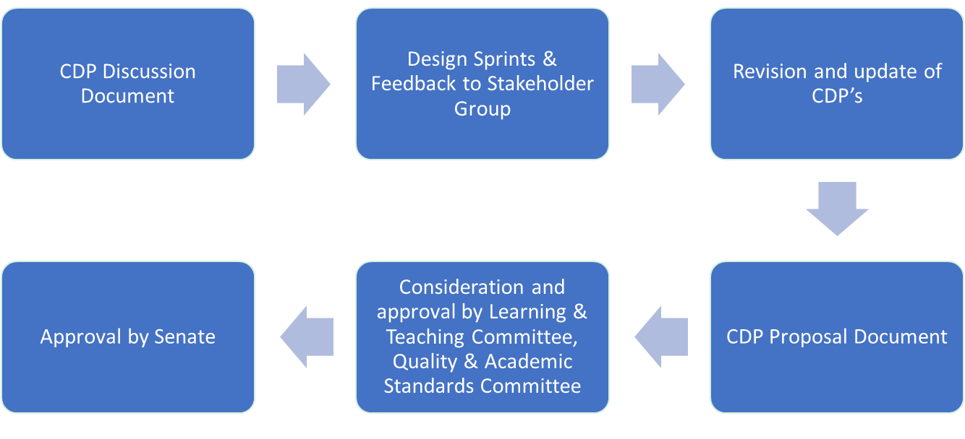

Programme Planning
- Programme development at UoD should be informed by research excellence, aligned to the Hallmarks & Graduate Attributes, and be underpinned by sound business principles, resulting in the development of a suite of undergraduate, taught postgraduate, research masters (MRes), executive, and professional doctorate programmes, that are best in sector and attractive to students nationally and internationally.
- The portfolio of programmes offered by UoD should meet actual student demand, notably international student demand, given that UG domestic demand is managed via Scottish Government-funded places. Our ambition for the unregulated income growth should be to match the levels of student participation seen at other comparable institutions.
- There should be a balance of risk within the University’s portfolio of programmes in, 1) established markets where there is existing student demand and the University has previously failed to attract students (and grow unregulated income), and 2) innovative programme development in new, emerging or untested markets.
  - As a general rule, ~80% of the School portfolio should consist of programmes where there is clear and demonstrable applicant demand. Students tend to be conservative in their choice of programme and well recognised degree titles are important for recruitment. This approach to risk provides schools with sufficient flexibility to explore novel and emerging markets, whilst retaining a focus on established markets.
  - Market research must be undertaken to support new programme ideas before they are submitted to the Programme Approval Group. The marketing team will support such requests, but in addition, we have developed a self-service tool, the Market Intelligence Data Analysis System (MIDAS), that searches HESA data sets. This provides historical information on the numbers of students studying programmes in the UK which can filter students by keyword, institution, study level, nationality, study mode etc.
- The development of new programmes now requires PAG approval and the initial approval process will consider overall fit to the School or University portfolio, high value collaborative partnerships, and opportunities for module sharing (within and beyond schools).
- All new programme proposals, and existing programmes undergoing Periodic Programme Review, should undertake a sustainability evaluation that will examine, national and international market demand, the potential for fee income generation, competitor activity through benchmarking, and establish programme fit within the School. This type of programme evaluation should inform which will be developed, retained or retired from the School/University portfolio.

Hallmarks and Graduate Attributes
- All programmes at the University of Dundee should incorporate a set of agreed Hallmarks and Graduate Attributes that define our education offer. The hallmarks describe the immutable features of a University of Dundee education and apply to all programmes. Graduate attributes describe the skills and competencies that each student will be able to demonstrate in their lives beyond their university experience.

Hallmarks
- The UoD is a beacon of excellence within Dundee, Scotland and the UK, providing it with a global reputation for high-quality education, first-class research, and impact. Our research informs the development of our degree programmes, providing students with a distinct learning experience. In addition, we are a civic university that draws from, and gives benefit to, the city.

- Research-informed education: The hallmarks of a UoD education should be rooted in its hard-earned reputation for research excellence. All UoD degree programmes should draw on these research foundations and evidence-led enquiry to inform programme design thereby ensuring that teaching & learning is world-class.
- Civic-focus: UoD is an anchor institution in the City providing education and training to students, many of whom enter the local workforce. Our programme portfolio should, where possible, align to the needs of the city/region and provide high-quality & skilled graduates to local employers.
- Academic enquiry and stretch: UoD degree programmes should encourage students to acquire knowledge, develop critical and evidence-based approach to academic study, and interrogate accepted norms. UoD programmes must offer academic stretch to allow students to challenge themselves and reach their full potential.
- Active/experiential learning: All programmes must include elements of active/ experiential learning in which students participate in practical, interactive or problem-solving activities. The assessment of UoD programmes should be designed to test knowledge, skills and problem-solving ability as they apply to both academic and real-world situations.
- Focussed & authentic assessment: Assessment will evaluate student knowledge & understanding and should align to programme learning outcomes first and module learning outcomes second. As students progress through a programme, assessment should develop a range of research, analytical and communication skills that are relevant to real world situations and employment
- Inclusive curriculum: UoD degree programmes should be relevant and accessible to students from all cultures and backgrounds by design. The curriculum design should foster the development of learning communities, consider the intended audiences and be designed to meet the needs of all students. We aspire to be a global institution and our students can expect a globally relevant curriculum.

Graduate Attributes
- These describe a range of qualities that graduates should realise from a UoD education as they embark on further study or move into the world of work. These are not typically subject-specific skills, but rather reflect an individual’s approach to the application of core knowledge to solve problems and develop approaches in real world situations for the benefit of mankind.
Fundamental graduate attributes might include:
  - Confidence aligned to self-efficacy
  - Resilience
  - Socially responsible, ethical, values-led & principled
  - Critical thinker
  - Innovative & creative problem solving
  - Curiosity about the world around them
  - Value equality, diversity & different perspectives
  - Desire to have impact and make a difference in a global world
  - Environmentally aware and sustainability-led
  - Agents of change
  - Data & digital fluency
  - Effective communication
  - Team working
  - Work/employment ready
  - Entrepreneurial mindset
  - Professionalism
  - Leadership
  - Research skills
- When developing a new programme in any discipline, programme teams should consider how the curriculum design can help develop these attributes. Some graduate attributes will be more relevant to certain programmes and others less so, but the programme documentation must demonstrate which attributes are developed as the student progresses through their chosen study path.

Programme Development & Curriculum Design:

High-Level Programme Design Principles
- All programmes should have a clear educational vision that is informed by the excellent research environment and aligned to the Hallmarks & Graduate Attributes of a UoD Programme, and best practice in each discipline. This will enable developers to identify unique features for new programmes that allows them to stand out from competition, i.e. developing a clear proposition and USP.
- Academic Champion: All programme development should be led by an academic champion who is typically a subject expert and will lead the programme development team through the CDP process. Academic champions will ensure that full academic consultation is undertaken, and that programme development processes, and quality assurance processes are followed.
- External stakeholders, e.g. PSRBs, employers, industrial partners and third sector organisations, will be engaged to assist with programme development where required.
- Students: Our students will be partners in the programme design process and will work alongside academic champions so that their input is heard and acted upon.
- Accreditation: Alignment of professional programmes to Professional, Statutory and Regulatory Bodies (PSRBs) requirements must be a primary consideration to safeguard regulatory approval and accreditation.
- Sector mapping & best practice: The programme development team will make itself aware of best practice in each discipline through sectoral comparison, use of subject benchmark statements and PSRB guidance (where available) and this will inform programme design.
- Pedagogical approach: Digital Champions and programme teams should determine the underpinning pedagogical approach to be used and ensure that it is followed.
- Clear Learning Outcomes: Programmes should be designed around a set of clear learning outcomes, draw from research knowledge in each discipline, align to the CDP hallmarks and allow students to develop and demonstrate the agreed graduate attributes (see 1 above). Module learning outcomes and any related assessments should align to programme learning outcomes.
- Teaching methods: The methods for delivering the curriculum and its assessment should be viable, engaging and inspiring, thereby enabling students to achieve learning outcomes in the most effective way possible. Teaching methods should be accessible to students from all backgrounds and cultures.
Academic champions and their programme development teams are encouraged to explore a diverse range of teaching methods and learning resources that will make each UoD engaging and unique. The Covid-19 pandemic stimulated many innovations in blended learning and has enhanced the University’s digital capabilities, and this learning should be drawn upon in all future programme development.
- Mode of delivery: The Programme Team should consider the primary mode of delivery at the outset, i.e. campus-based, distance learning/online or blended. We should increasingly encourage multi-mode delivery for core programmes where there is demonstrable demand. Lessons learned from the Covid-19 pandemic in terms of staff upskilling, increased used of digital platforms, digital tools, blended learning, hybrid delivery and e-assessment, should be incorporated into discussions about future programme design.
- Programme/pathway identity: Each programme should be distinct and where pathways are offered, they should align with both the ‘parent programme’, and have unique features, i.e. module combinations. It is important for each programme/pathway to demonstrate a clear identity to ensure that different degree awards cannot be achieved by choosing the same module combinations.
- Programme coherence: Programmes should comprise a coherent set of core modules and/or options that collectively address programme level learning outcomes and be able to demonstrate the development of knowledge and skills, as students progress through the programme.
- Employability: All students should have the opportunity to undertake personal development opportunities (employment readiness), engage with employers, experience entrepreneurship, undertake internship/work/ business-related activity & participate in study abroad activities as part of their programme (credit and non-credit bearing).Related to this, UoD should develop a credit-bearing internship shell module that is available to all students (mostly non-professional courses) that can be customised to meet the needs of different disciplines. The rationale for assigning credit to employment-related activities is to encourage participation, although these activities will be voluntary in nature, and no student will be disadvantaged as a result of non-participation.
The development of employability-related resources will be led by the Careers & Employability Service who will advise on ideas for embedding employability skills within and around the curriculum.
- Study checkpoints: Essential study checkpoints, e.g. attainment of threshold concepts, work/placement experience, should be mapped within the programme structure.

Design Principles
- Once the high-level programme design is complete, detailed curriculum design will be undertaken to ensure that the hallmarks are embedded in individual modules and that opportunities exist from students to develop the agreed graduate attributes.
- Subject benchmarking & QA: All programmes should be aligned to national subject benchmarks (Scottish Credit & Qualifications Framework Descriptors for levels 7-11), Subject Benchmark Statements (QAA) and align with the UK Quality Code for Higher Education (QAA).
- Curriculum content/syllabus will be designed by the programme team and discipline experts and will align with the high-level programme design principles. Student representatives should be included in the development of the curriculum content and syllabus. The international nature of the institution and its curricula should be evident in the content.
- Research-informed curriculum: A research-informed Apex Project/Dissertation/Final Year Project should be part of all programmes, and programme teams must ensure, and be able to demonstrate, that research -informed and evidence-based teaching is embedded throughout the entire curriculum?
- Design for inclusivity: All new UoD curricula should be inclusive by design, relevant to students from different cultures and backgrounds, foster learning communities and develop understanding in a global world. Teaching and assessment styles should be relevant to students from different backgrounds, case studies & examples should be broad-based, and must be supported by appropriate learning resources. The Periodic Programme Review process will require existing programmes to review the inclusivity criteria available in the learning resources and modify programmes to ensure that they conform.
- Teaching methods: Teaching approaches should be clearly identified, and be diverse in order to make the programme interesting and to stimulate student engagement, e.g. active/experiential learning, problem solving activity, analytical skills, academic discussion and debate, lecture, design activities, meet the expert, development of practical/ laboratory/clinical skills and knowledge etc?
- Blended learning: Programme teams should consider to what extent a high-quality blended learning approach can be incorporated into modules, e.g. to support self-directed learning. This might be achieved through lecture capture, podcasts, online tutorials and online assessment. Such flexibility may be useful, particularly for students with caring responsibilities, or who need to work alongside their studies.
- Digital skills: All programmes should map digital skills across the curriculum to ensure that students have ample opportunity to develop and apply these skills. Consider how digital skills will be developed as learners progress through their programme.
- Transferable skills: Where possible transferable skills, e.g. writing, communication, problem solving, should be embedded within modules so that they can be developed in an applied manner/environment.

Programme Structure:
- Core & optional modules: The programme team will determine the balance of core and level of module optionality to provide students with a transparent, coherent and flexible programme structure that is easy to follow. Throughout the curriculum journey, acquisition of knowledge, development of understanding, and the acquisition of skills, should be clearly mapped and linked to the relevant SCQF levels and subject benchmark statements.
- Student choice: Where optional modules are offered, the level of choice should be sufficient to satisfy student interest and preferences but managed so that each module is viable and organisational efficiency is achieved. A minimum module enrolment of ~15 FTE at Undergraduate or TPG levels is suggested, although discretion will be given to Schools to justify any departure from normal practice at the programme approval stage.
- Excessive or confusing module choice should be avoided since this can impact programme coherence, result in large numbers of modules with poor enrolment, and increase organisational inefficiency and timetable/assessment issues. Teams should consider ways of presenting module choice that groups related or compatible modules to improve programme coherence (Appendix 1).
- Teaching efficiency must be considered, where academically justified, by limiting the number of low credit value modules. If cognate modules can be combined/merged, this provides opportunity for team-based teaching, reduces siloed learning, encourages a synoptic approach to learning, and opportunities for synoptic assessment. Moreover, it reduces risk associated with staff absence and increases organisational resilience. Smaller specialist modules may be more appropriate in honours years where specialist teaching is more common

Assessment and Feedback
- We must ensure that all programmes are aligned to the Quality Code which suggests incorporation of a systematic, relevant and stimulating assessment strategy, that enables programme and module learning outcomes to be met, and to the University Assessment Policy. A set of assessment and feedback resources is available for staff to guide them through the design of programme and module level assessment, e.g. TESTA. Further resources will be added by sharing examples of good practice from newly developed programme documentation.
- What is the purpose of assessment?
- to determine whether students understand curriculum content and have achieved programme and module learning outcomes.
- to allow students to develop key skills essential for their development
- to allow students to engage, monitor personal progress, reflect, and enhance understanding.
- How should we assess learning outcomes? Assessment of core modules/options should align to programme learning outcomes first and module learning outcomes second. This ensures that assessment is coordinated across the programme and between modules. This is most easily achieved where programmes have a coherent structure and curriculum journey (see section 3.3)
- How do we ensure that assessment workload is fair for students? Programme leads should ensure that the student workload for each module is appropriate and that there is parity with other modules of equivalent credit value.
The number of independent study hours required to complete the assessments for a module of a set credit value should operate within a defined range. This ensures that different module combinations do not result in excessive or reduced student workload.
- Assessment and the development of skills? Assessment comes in many forms and programme developers are encouraged to think about how assessment strategies can develop a student’s transferable skills as they progress through their course by revisiting modes of assessment.

- Assessment planning/congestion: Each programme should develop an assessment matrix that shows the formative and summative assessment tasks and schedules these so that student workload is effectively managed.
There are three benefits to organising assessment in this way; 1) reduction of assessment congestion, 2) it helps students to manage their workload, and 3) effective management of staff marking workloads.
To assist with the development of an assessment strategy, the Transforming the Experience of Students through Assessment (TESTA) process is included as a mandatory component of new programme development and Periodic Programme Review, and guides programme developers through an audit of formative/summative assessment and feedback.
- Feedback: Programmes and modules must declare how feedback will be provided for different assessment elements within a module, include clear marking rubrics for each type of activity, and publish these on My Dundee. Feedback should be planned, scheduled, and be clearly identified as a feedback activity so that it is obvious to students how and when feedback is being provided.
Feedback should be provided in different forms, e.g. individual detailed written feedback on written work, oral feedback and discussion with advisers of study, generic class feedback on overall performance, provision of worked examples (good and bad).
Feedback training is provided to staff, but in general, any feedback must be clear, concise and avoid vague or general statements that are difficult to interpret. It should identify both strengths and weaknesses within a student’s work so that they know which areas to focus on in future.
Students must be provided with training so that they understand the purpose of feedback, the range of feedback provided, how to respond to feedback and how to improve future work based on feedback. Examples of feedback methodologies and resources are available to staff to review online to assist with the development of feedback strategies for programmes and modules.

Curriculum Design Principles Project Steering Group
- Blair Grubb (Vice-Principal, Education)
- Erica Russell-Hensens (Quality & Academic Standards lead)
- Natalie Lafferty (Digital Education lead)
- Linda Martindale (Enhancement Theme lead)
- Carrie McLennan (Pedagogy lead)
- Shona Johnston (Employability lead)
- Joan Robertson (ED&I Lead)
- Martha Umeh Ude-Eze (Vice-President, Academic, DUSA)

Curriculum Design Principles Project Stakeholder Group
The stakeholder group is necessarily large to ensure that all voices are heard and that staff with knowledge of subject specialism, regulatory matters and accreditation are consulted.
- UEG – Vice-Principal (Education) – Blair Grubb
- Director of Quality and Academic Standards – Erica Russell-Hensens
- School Associate Deans for Learning and Teaching (x10)
- School Associate Deans for Quality (x10)
- DUSA President – Scott Quinn
- DUSA Vice-President, Academic – Martha Umeh Ude-Eze
- Student representatives (x 5 or more if needed) –DUSA nominated students reresentatives
- Director Library & Learning Centre -Richard Parsons
- Member of the staff BAME network – Mohammad Islam
- Member of Disabled Staff Network – Steve Cavill
- Member of the LGBT+ Staff Network – Erin Hardee
- Director Centre for Innovation in Learning & Teaching (CITL) – Natalie Lafferty
- Assistant Director & Head of Academic Skills Centre (ASC) – Dr Lorraine Anderson
- Director Careers and Employability Services -Shona Johnston
- Head of English for International Students – Amanda Shaw
- Enterprise and Entrepreneurship Manager, Centre for Entrepreneurship – Brian McNicoll
- Director of Registry – Lesley Sinclair
- Member of External Relations, Marketing & Communications – Rebecca Trengove & Shane Collins

References
Scottish Credit and Qualifications Framework (2020) https://scqf.org.uk/about-the-framework/
Scottish Credit and Qualifications Framework Descriptors (2012) SCQF-LevelDescriptors.pdf (sqa.org.uk)
The UK Quality Code for Higher Education (2018) https://www.qaa.ac.uk/quality-code
University of Dundee: Assessment policy for taught provision. https://www.dundee.ac.uk/corporate-information/assessment-policy-taught-provision
Fenton J & Smith M (2019) You Can’t Say That!’: Critical Thinking, Identity Politics, and the Social Work Academy. https://policyexchange.org.uk/publication/academic-freedom-in-the-uk/
Academic Skills Centre TESTA Resources; https://www.dundee.ac.uk/academic-skills/for-staff/assessment-and-feedback-hub/testa/

Examples of curriculum design processes operating or under development at other universities.
Curriculum Principles, University of Bath: https://teachinghub.bath.ac.uk/curriculum-principles/
Curriculum 2021, University of Liverpool: https://www.liverpool.ac.uk/media/livacuk/centre-for-innovation-in-education/curriculum-2021/c2021-booklet.pdf
Principles for the development of the taught curriculum, University of Durham: https://www.dur.ac.uk/learningandteaching.handbook/3/principles/
Curriculum design - the essentials, University of Sheffield: https://www.sheffield.ac.uk/staff/elevate/essentials/curriculum-design-1#
Inclusive Curriculum Framework, Kingston University, London: https://www.kingston.ac.uk/aboutkingstonuniversity/equality-diversity-and-inclusion/our-inclusive-curriculum/inclusive-curriculum-framework/
Dilly Fung: A Connected Curriculum for Higher Education https://discovery.ucl.ac.uk/id/eprint/1558776/1/A-Connected-Curriculum-for-Higher-Education.pdf
Advance HE: Inclusive Curriculum Inclusive curriculum | Advance HE (advance-he.ac.uk)
Related to Gradaute Attributes - IB learner profile which helpfully explains each attribute: https://www.ibo.org/contentassets/fd82f70643ef4086b7d3f292cc214962/learner-profile-en.pdf
University of Edinburgh: Student-Led, Individually-Created Courses (SLICCs) https://www.ed.ac.uk/employability/slicc/about

Appendix 1A
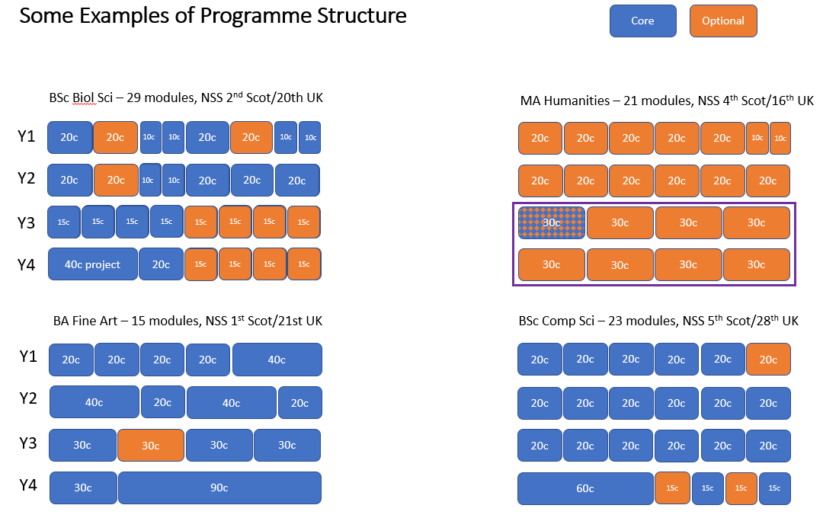

Appendix 1B
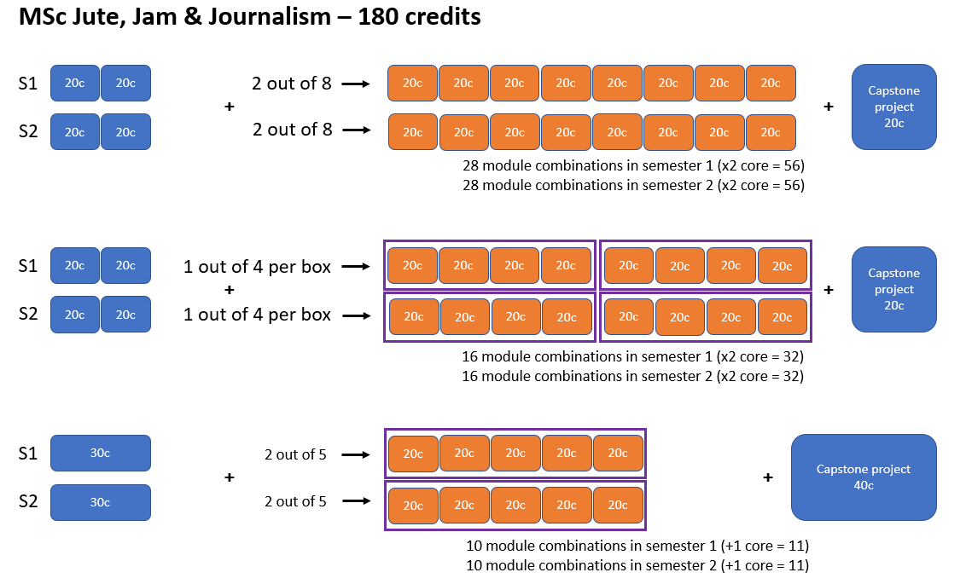

Document Name | Curriculum Design Principles
Status  Responsible officer/department/school  Policy owner  Date last approved  Due for renewal  Information classification: public/internal  Approval route and history | Final  Academic and Corporate Governance  Quality & Academic Standards  26 May 2021  26 May 2023  Public  Doctoral Academy Board 29 April 2021  Programme Approval Group (PAG) 30 April 2021  Quality & Academic Standards Committee (QASC) 5 May 2021  University Executive Group 19 May 2021  Learning & Teaching Committee 11 May 2021  Senate 26 May 2021
Code | PDPG_v001

This may include the award of credit as well as the award of a qualification
See the Glossary for definitions of these terms
The term ‘course’ is often used interchangeably with either programme or module. Course is typically used during the admissions stages to mean a programme and aligns with the language used by UCAS and others.
The University will maintain centrally held registers of certificated courses including MOOCs.
Temporary suspension of a module or programme will only be permitted in exceptional circumstances, for example where a module or programme leader is on sabbatical or maternity leave, suspension will typically only be granted for the period of one calendar year, after which the module or programme should be reinstated or withdrawn. The QAS team can provide additional guidance as required.
Exceptions to this may be agreed with External Relations if level of applications or a partnership arrangement supports an intake without recruitment/marketing activities taking place.
These timelines are indicative only and are dependent on a range of factors including the scale of the proposal, quality of the proposal submitted, impact on student experience or teach-out arrangements etc.
Approval should be in place at least 12 months prior to the first intake. (See 4.4)
Where there are circumstances outwith the University’s control, every effort will be made to mitigate against any adverse impact on current students and applicants.
The Responsible Person may wish to bring together a team of colleagues to support development of a proposal.
Where proposals involve multiple Schools, it may be deemed appropriate to convene a combined SQASC meeting including a representative selection of members from each SQASC and chaired by the lead School. This approach may be taken where each of the involved Schools Associate Dean’s for QAS is in agreement.
Where proposals involve multiple Schools, it may be deemed appropriate to convene a combined SEG meeting including a representative group of members from each SEG and chaired by the lead School. This approach may be taken where each of the involved Schools Dean’s is in agreement.
Each programme should be distinct and where pathways are offered, they should align with both the ‘parent programme’, and have unique features, i.e. the core modules will align with differing option module combinations. It is important for each programme/pathway to demonstrate a clear identity to ensure that different degree awards cannot be achieved by choosing the same module combinations. See Glossary.
Where a degree regulation change is made as a result of changes to the programme or University policy a separate consultation and approval need not be undertaken and the regulations, once approved by the relevant School committee(s) should be reported to the QAS office for noting by the Quality & Academic Standards Committee
The Responsible person may work together with a team to develop the proposal this may include colleagues from a range of directorates and/or Schools as appropriate for the project.
Information about the Consultation and Engagement event can be found in Appendix B
FutureLearn is a company owned by The Open University, providing free online courses from universities and other organisations. See https://www.futurelearn.com/.
See http://www.jisc.ac.uk/blog/so-what-are-open-badges-28-aug-2013 for more information on Open Badges.
A suggested risk appetite is 80% of new programmes targeted at established markets and no more than 20% of programmes targeted at new markets.

