Disability Services - Annual Report - AY 22/23
Dr. Shirley Hill, Head of Disability Services, 9th August 2023

1. overview

This has been a very challenging academic year due to the increasing demand for support from Disability Services and a number of staff absences, including as a result of ongoing strike action. The first semester was extremely busy and the team were under significant pressure. This led to delays in our response to email correspondence and longer waiting times for appointments which likely impacted on the student feedback we received as this was less positive than previous years.

Recruitment of new/replacement staff in January helped to reduce the pressure but the Service remains under resourced to meet the needs of increasing numbers of disabled students seeking support and the increasing complexity of their support needs. In addition, the cost of such support may not be funded externally, particularly for international students, or exceeds that available through the Disabled Students’ Allowance, putting additional strain on limited resources.

It is anticipated that the planned recruitment of an additional 1FTE Disability Adviser will help to support the delivery of more efficient and responsive services next academic year, reduce the workload and associated stress for staff and improve the experience of students accessing our services. Additional administrative support was not approved in the most recent investment bid but should be reconsidered next financial year to support the delivery of efficient services, given the ongoing increase in demand. Service budgets should also be reviewed to reflect the changes in the student demographic seeking support from Disability Services.

As this is my last annual report before retiring from the University at the end of August 2023, I would like to thank my Disability Services’ colleagues for the excellent work they continue to do in very challenging circumstances and for their ongoing commitment to their roles. Their support has been invaluable and I wish them the very best for the new academic year and beyond. I would also like to thank all those colleagues who have supported the Disability Services’ team over many years to enable and improve access for disabled students and staff.

2. Key Facts and Figures for AY 22/23

- Over 2,300 students were registered with Disability Services during AY 22/23; an increase of 10% compared to the previous AY. This excludes students who accessed the Service in AY 22/23 but graduated in November 2022. The number of students registered with our Service has increased every AY for the past seven years. The complexity of students’ support needs has also increased.

- It is not possible to provide an accurate breakdown of the nature of the disabilities students disclosed to Disability Services this AY due to a HESA coding issue (see Service Developments section below). That aside, of those students who have a disability code on SITS, the majority disclosed specific learning difficulties or mental health difficulties. There has also been an increase in the number of students disclosing ADHD and contacting Disability Services for support.

- An additional 649 students contacted our Service for advice and support during AY 22/23. This includes students who are pending registration, awaiting dyslexia screening/diagnosis, prospective students and applicants, and students with temporary disabilities.

- 345 students had a DSA study needs assessment through our Access Centre service (including 76 students from other Universities and Colleges); an increase from the previous AY. At time of writing, 33 students had already been referred for a DSA needs assessment for AY 23/24.

- 138 dyslexia screenings and 92 diagnostic assessments for dyslexia were completed during AY 22/23 with 65 students receiving a positive diagnosis. The introduction of an online screening test has significantly increased the number of screening appointments we can offer. However, it has also led to a small decrease in the number of students who subsequently receive a positive diagnosis suggesting that the online screening tool may be generating false positives.

- Excellent feedback was received from the majority of students who accessed our services and responded to our online survey (key points are summarised in 3. below). There was a decrease in overall satisfaction with our services, however, which is likely due to the significant delays in our response times to email communication and long waiting times for appointments in semester one.

- Income generated through our DSA related services was circa £40k; similar to AY 21/22.

- 124 disabled staff were registered with Disability Services for confidential advice and ongoing support in AY 22/23; similar to AY 21/22.

3. Student Feedback Survey AY 22/23 - Key Results

(see Appendix 1 for further details and sample comments)

- 192 students responded to our online survey (7% response rate), across all 8 Schools and disclosing a range of disabilities.

- 76% rated all aspects of our services as good or very good; lower than previous years and likely due to staff absences in semester one and long delays in our email response/appointments.

- Suggested improvements to Disability Services included: improving our response time, increasing appointments, and following up with Schools to ensure support implemented.

- 50% students rated support from their Academic School as good or very good; this figure increased to 82% including ratings of satisfactory; slightly lower than previous years.

- Suggested improvements included: ensuring adjustments are implemented, providing mandatory disability awareness training, and clarifying processes to access support.

- 34 students responded to our Access Centre online survey from a range of institutions (10% response rate); a much lower response rate than previous years and likely due to a change in our administration processes. This will be reviewed for AY 23/24.

- Average rating (out of 5) for all aspects of our Access Centre service was 4.5; on a par with previous years.

- The only suggested improvement to our Access Centre service was to reduce waiting times for DSA needs assessment appointments.

Feedback and Planning

We are very grateful for all the feedback we receive and appreciate students taking the time to provide this. All feedback is discussed as it arises during the academic year and reviewed as a team at our annual feedback/planning meeting. We aim to respond to suggested improvements where we can, within the limits of existing resources. We also discuss feedback with Disability Support Officers (DSOs) in Schools and Directorates at our DSO meetings, and follow up with individual Schools/Services as appropriate.

Key actions from feedback this AY and from our team planning meeting include:

- Improve response times to email correspondence
- Reduce waiting times for appointments
- Increase contact/check ins with students throughout the year
- Ensure follow up after initial meeting with Adviser
- Improve support for postgraduate students
- Improve follow up with Schools to ensure support/adjustments implemented
- Provide disability awareness training for University staff
- Raise awareness of specific disabilities and impact on studies
- Improve communication with students and clarify points of contact in Schools
- Clarify and simplify access to academic support such as extensions
- Improve accessibility of teaching materials
- Improve access arrangements for graduation ceremonies
- Increase support for student mental wellbeing
- Provide more-in person appointments for Access Centre assessments
- Improve accessibility of Disability Services’ reception
- Provide additional drop-in sessions for students to ask questions
- Offer training to staff on accessing students’ adjustments
- Raise awareness of SEAtS attendance management issues for disabled students

4. Service Developments

- There were a number of staff changes in our team this AY with Jackie Ritchie joining us in January as a Disability Adviser on secondment from DJCAD to provided maternity cover for Anna Stafylarakis. Jackie has subsequently been successfully appointed to a permanent Disability Adviser post from 1st September 2023 following the retiral of Kerry Penman. Darren Brown joined us as our new Administrator in October (replacement for Piotr Kielinski), Sarah Fleming joined us in January to take up a new Disability Adviser post and Rhona Payne also joined us in January as our new Assistive Technology and Alternative Formats Officer (replacement post that had been vacant for some time). All new staff have settled in well to their roles. I will be retiring from the University on 31st August 2023, after 37 years. My successor, Andy McMahon, started on 7th August allowing a period of handover before I leave.

- Rhona Payne has liaised extensively with colleagues in CTIL, DTS and Registry to improve access to assistive technology in exams for disabled students and to test the accessibility of the University’s assessment systems. This has helped to address some of the issues students have experienced in previous years. Rhona has also reviewed our assistive software loan licence agreements and progressed renewals with suppliers, taking account of the potential impact on students of changing from one product to another.

- We continue to offer confidential advice to disabled staff who contact our Service for the first time and Sarah Fleming is our lead Disability Adviser for this support. Sarah has been working with the Disabled Staff Network to discuss issues and develop support resources for disabled staff. We also direct staff to other sources of support in the University, including through Occupational Health, the Counselling Service and the University Health Service, as well as directly from their line manager, HR Officer and Union representative where relevant. Ongoing support for staff already registered with our Service continues.

- Claire Sutherland ensured our transition event for students with autism spectrum disorders or mental health difficulties was successfully delivered in person again this year and also arranged the opportunity to stay in residences for the first time. Our thanks to colleagues across the University who contributed to this event (see Appendix 2 for further details).

- We attended Open/Visit Days for prospective students and applicants during AY 22/23 to provide information on the support available to disabled students at Dundee University and to answer any questions. We also offered two, in-person drop-in sessions during Welcome Week for new and returning students.

- Existing student support contracts/consultancy agreements have been reviewed with Procurement and approved for a further year. A re-tender for our Non-Personal Medical Help Service (currently awarded to Randstad) will need to be progressed by June 2024.

- The accuracy of data for the number of students disclosing specific disabilities has, unfortunately, been affected by the change in the HESA disability coding that was introduced in August 2022 that removed the multiple disabilities category. This means that it is not currently possible to code students who disclose multiple disabilities to the Disability Services’ team and their disability category on SITS/eVision is blank unless just one category of disability is selected. An enhancement to eVision to address this issue was raised at the time and is currently being progressed with support from DTS and strategic planning.

- An additional SITS/eVision enhancement is also being progressed to improve access to exam adjustments for Registry, CTIL and Schools. Further enhancements are being considered to enable greater access for students to details of their support arrangements.

- An additional question was included in our student feedback survey this year to assess the impact of the move to hybrid working on student appointment arrangements. The results indicated that there is no clear preference for meeting in person or remotely with a Disability Adviser and suggest that the flexibility to choose meeting arrangements should continue to be offered to students seeking advice or support from Disability Services.

Staff Development and Delivery of Training
Staff development activities completed by Disability Services’ staff this AY included:

- Mandatory EDI, ISAT and UCAS embargo training
- BSL Level 1 certificate
- Understanding Autism Level 3 certificate
- Supporting Students and Staff with Autism
- Supporting Students and Staff with Mental Health Difficulties
- ASSIST and SafeTalk training
- Living with ADHD (NADP Webinar)
- Gender based violence
- Complaints handling
- Data protection
- Vision Aid training
- iHear training
- OrCam and scanning pen training
- iDiversity AT workshop event
- TechEdology AT Brunch
- Webinars on Ayoa, Booost, Jamworks, Dragon and Present Pal software
- TalkType software training
- Glean notetaking software training
- Creating Accessible Web Content
- Creating Accessible PDFs
- Portable firefighting training

The Disability Services’ team also delivered training to students/staff this AY, including:

- Student Ambassadors – disability awareness training
- Summer School students – introduction to Disability Services
- Disability Support Officers – disability awareness training
- Disability Support Officers – overview of assistive technology to support learning/work
- OPD (available to all staff) – disability awareness training, mental health first aid training
- PGDE course students - introduction to Disability Services (August 23)
- Health Sciences staff - introduction to Disability Services (September 23)

It is hoped that the appointment of an additional 1FTE Disability Adviser next AY will enable the team to increase our involvement in the delivery of disability-related training for staff and students.

Appendix 1

Disability Services - Summary of Student Feedback – AY 22/23

1. Overview

All students who were registered with or contacted Disability Services during AY 22/23 (over 2900 students) were invited to complete an anonymous online survey (via the JISC Online Survey service) to provide feedback on Disability Services as part of our annual feedback and planning.

In addition, students who attended our Access Centre for a needs assessment in connection with their application for the Disabled Students’ Allowance were asked for their feedback on their experience utilising MS Forms (346 students had completed their needs assessment at time of writing and 34 had provided feedback). This response rate is much lower than previous years and is likely due to a change in our administration which will be reviewed for next academic year.

In total, 192 students responded to our online survey (7% response rate) across all 8 Schools and disclosing a range of disabilities:

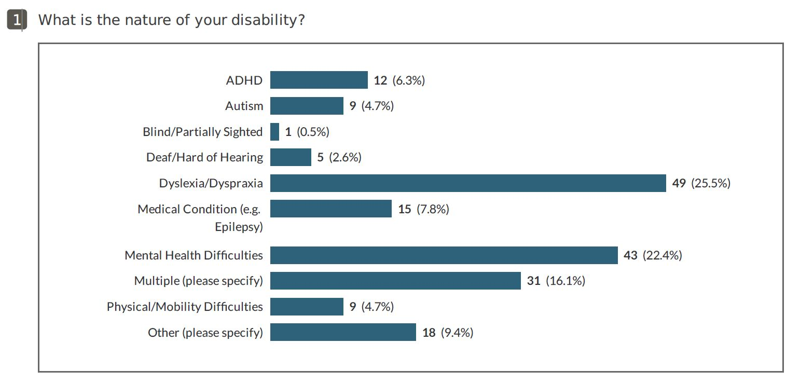

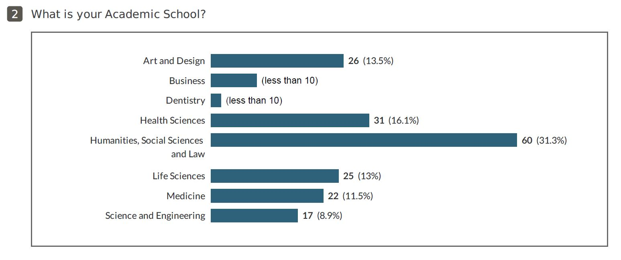
An additional question was included in the survey this year to assess the impact of the move to hybrid working on student appointment arrangements:
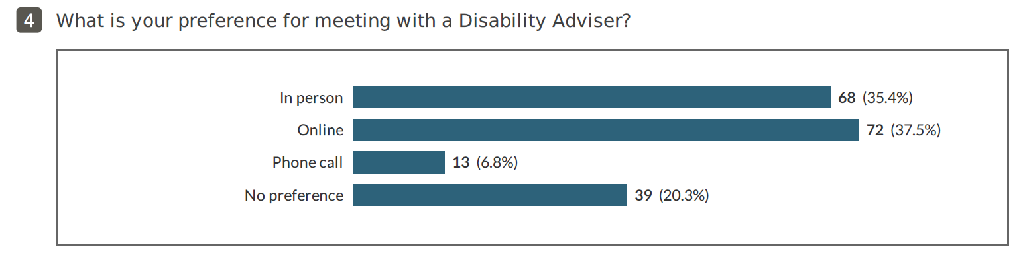
The results indicate that there is no clear preference for meeting in person or remotely with a Disability Adviser and suggest that the flexibility to choose meeting arrangements should continue to be offered. Most Disability Advisers currently work on campus for the majority of their working week so we can offer this flexibility, arranging meetings in person or online/by phone as needed to meet students’ needs and preferences.

2. Feedback on Disability Services

Advice and support provided by Disability Services – 76% rated good or very good (84% in 21/22)

The decrease in overall satisfaction with the advice and support provided by Disability Services is likely due to the extremely busy first semester when waiting times for an appointment exceeded two months and we were unable to respond to email correspondence within a reasonable timescale. This was due to a number of staff changes/absences, in particular ongoing strike action.

Example Comments on Disability Services support

The disability services have been very consistent and helpful in my learning. Whilst I haven't been provided with an in-person enabler like I have previously, I still feel very supported by the college and by Randstad who have provided me with additional confidence and helped me make sense of challenging periods.

Very understanding and caring. Seems to genuinely want the best.

It is nice to have everything available, sometimes it can take a wee while to get a response or a meeting which can be stressful but everyone involved is very lovely. Definitely makes my time at uni a lot easier.

Disability Services have been really helpful in getting me access to an ergonomic keyboard and checking I'm okay using it. They don't harass me with lots of check-ins, but they are there if needed. Great!

Very understanding and easy. Made me feel like I wasn't messed up or something like that, rather that I was just normal

Throughout the past few years, I have had several appointments and interactions with the disability services team, and on each occasion, the staff members have made me feel incredibly comfortable and have gone above and beyond to assist me. My only concern lies in the accessibility of obtaining an appointment, but other than that, the department is exceptional.

They have been amazing in helping me get through my course. Not sure I would still be here without them.

My advisor was amazing. Always replied to emails in time and provided ample support during exams and listened to me intently. She also helped with special arrangements during exams which were extremely beneficial for me

This service is amazing and I am so glad I have been able to access this support

I am really grateful for the support provided by my adviser through Disability Services. They have helped me greatly and provided practical support and digital programmes to aid my learning. My advisor has also helped me develop skills which will be invaluable managing the next phase of my studies and the world of work.

The disability services team was crucial to my success in the first two years of university. Their dedication and expertise were invaluable, and I'm grateful for their guidance and support.

Staff in 5years studying here have been exemplary in support given and are perfectly understanding of changing circumstances

I was grateful to have been provided a dyslexia screening as although it came back negative it did show that I am below normal in some areas of spelling and reading and not only has that validated my feeling but it has also made me feel more supported by the service along with their aid to my mental health conditions

Really supportive and encouraging for me getting support and help. Also very understanding with the nature of the difficulties I faced and tried their hardest to make my university experience as best as possible for me.

Although busy I was given great support, advice & communication throughout a dsa process

The support I received from ‘Adviser’ was brilliant. For the first time since I became disabled, I felt understood and listened to - more so than I have with all medical professionals that I have interacted with. I could not praise her efforts and support enough.

The Disability Services team are fantastic. ‘Adviser’ is extremely knowledgeable and understanding and, most importantly, very supportive and empathetic. Thank you for everything. I would be lost without the team.

Disability services have provided me with an exceptional level of support and have done everything they can to make sure I was able to enjoy and manage my first year at uni academically. Staff within the disability are all very kind and approachable which definitely made seeking out support a lot easier. Overall fantastic service

The receptionist is lovely and very welcoming. And the staff are really nice and have helped and supported me with my difficulties, providing me with the equipment needed to support my Dyslexia.

I had not had validation like this before about my personal issues and really appreciated the support, kindness and advice. My meetings were comforting and provided a space that felt really safe and judgment free.

I think this is a fantastic service that I would strongly advice students to access if they feel they need extra support.

disability services - suggestions for improvement (including difficulties):

- Improve response times to email correspondence
- Increase availability of appointments to reduce waiting times
- Increase contact/check ins with students throughout the year
- Ensure follow up after initial meeting with Adviser
- Improve support for postgraduate students
- Improve follow up with Schools to ensure support implemented
- Provide disability awareness training for University staff

3. access centre - feedback on dsa needs assessment service

In total, 34 students provided feedback on their Access Centre assessment experience (out of 346; 10% response rate) from a range of institutions. This response rate is much lower than previous years and is likely due to a change in our administration which will be reviewed for next academic year.

Average ratings (out of 5):

Assessment guide 4.3; Needs assessment interview 4.7; Equipment trial 4.0; Assessment report = 4.8

Average ratings were on a par with AY 21/22 with the exception of the equipment trial rating which was lower. This is Iikely due to the online delivery of the majority of DSA needs assessments this AY which will be reviewed next year to increase the availability of in-person assessments.

Example Comments on access centre DSA needs assessment service

My experience has been great, the people I’ve spoken with have all been lovely, understanding and very supportive. I would highly recommend the service to those who need it and I’m extremely appreciate of the support I am receiving. It’s easing my anxiety by knowing that I can ask for help whenever needed. Thank you!

My DSA assessor was excellent, very supportive and patient

It was an easy experience and I feel assured that I will get help needed to complete my degree. Thank you.

I found the assessor to be friendly, professional, and reassuring that he was there to help.

I felt understood and valued - a vast contrast to my recent assessment by the DWP

Everything has been excellent and staff have been amazingly helpful and kind. I felt heard and not judged which made all the difference.

Access centre - suggestions for improvement (including difficulties):

The only suggestion for improvement was to reduce waiting times for DSA needs assessment appointments.

4. Academic School Support

- Support provided by Academic School – 50% rated good or very good (82% including satisfactory) (57% and 84% respectively in AY 21/22)

example Comments on Academic School support

I needed an extension on a report and this was accepted very quickly especially due to me being with the disability services

The support provided by my Academic School has been very direct and to the point, and has pushed me in the right direction with my work. It hasn't always been easy, but I have found their support and advice very engaging and productive.

The academic school I am part of has been incredibly supportive in providing me with a smaller exam room and maintaining regular communication regarding my specific needs during the exam season.

My school has also provided great help, and have showed me sympathy and flexibility when it came to assignments. Sometimes would get in touch with me asking if everything was okay if they noticed that I was not always there.

Tutors helped with meetings to settle issues I had thought of etc. However this is a bit rarer depending on the time of year as work load for tutors increased and there wasn't enough tutors to go round!

Not always clear who to contact. Often have to wait for a reply or re- email them. Sometimes get sent to email other people making acting support more confusing.

My AOS has been a godsend this year; she has supported and encouraged me throughout this year and went beyond what she needed to do by spending time to call me and support me understand the essay questions and things from placement. I wouldn't have made it through third year without her supporting me!!

There appears to be a disconnect between the supporting measures put in place via the Disability Service to the measures being implemented by the school. I felt responsible for ensuring these measures were put in place for me from tutor to tutor, and had to advocate for myself by emailing the school secretary or speaking to tutors directly. It was not easy to do that given attending university for this course was the first time I was studying on campus with a disability.

Although understanding was granted around deadlines, the recommendations around in class support such as having slides or reading in advance were never adhered to.

5. general comments and suggestions for improvement

Example Comments on disability support generally

In my own experience the disability services and university has been a great resource and has helped me a lot with my mental health as well as giving me hope when it came to my struggles mixed in with university work.

Don't hesitate to reach out to the university team if you ever feel anxious or worried. They are always available to provide assistance and ensure that you feel welcome and heard.

They're extremely busy and understaffed. Getting help at the beginning of the school year is almost impossible because of the limited number of people and a huge influx of students that need help.

The university genuinely cares and they go out of their way to ensure a student is adequately supported.

I understand that many students come forward to access support and need support in all shapes and sizes. Be consistently kind and try and find solutions to help because you could change their entire experience of uni from struggling to feeling academically empowered. Never underestimate the power of your support.

I just want to thank the university for assisting me in all of my academic endeavours. Without the level of support I would not have successfully managed to complete the three years of my degree. And I go into my final year confident that I will graduate as a result of this support and assistance

In my own experience the disability services and university has been a great resource and has helped me a lot with my mental health as well as giving me hope when it came to my struggles mixed in with university work.

Suggestions for improvement (including difficulties experienced):

- Ensure adjustments identified by Disability Services are implemented by Schools
- Provide mandatory disability awareness training for all staff
- Raise awareness of specific disabilities and impact on studies
- Improve communication with students and clarify points of contact
- Clarify and simplify access to support such as extensions
- Improve accessibility of teaching materials
- Improve access arrangements for graduation ceremonies
- Increase support for student mental wellbeing

Appendix 2

Disability Services Transition Event – 4th July 2023
Report by Claire Sutherland, Disability Adviser

INTRODUCTION
Disability Services hosted a transitions event on Tuesday 4th July 2023 to support applicants disclosing Autism Spectrum Disorder (ASD) and/or mental health difficulties, with their transition to University. The aim of the event was to provide key information about the student experience and support at the University of Dundee in a supportive environment for those who may experience difficulties with the potentially overwhelming amount of information provided during Welcome Week. An associated information module on My Dundee was also updated and access was given to participants.

Applicants were invited to complete an event registration form following an email invite from Admissions who contacted applicants disclosing ASD or mental health difficulties on their UCAS application. Any applicants who had already contacted Disability Services to discuss their support needs for AY 23-24 were also advised of the event by their Disability Adviser or were contacted by the transitions team. All applicants were advised they could bring a guest to the event if they would like to do so. The total number of attendees was limited to provide the supportive environment needed for this event.

The event was organised and facilitated by Disability Advisers, Claire Sutherland and Sarah Fleming. Rhona Payne, Assistive Technology and Alternative Formats Officer, also attended to provide a presentation on the use of assistive technology to support learning and provided IT support for those students joining remotely. Sessions were also recorded and added to the online module.

NEW FOR 2023
In addition to the usual Transitions Day, Disability Services worked with the ResLife Support Team in Student Services to offer a residential stay for participants who wanted the opportunity to experience living in University halls and to engage in activities to help support the transition to independent living. Guests were invited to arrive on Monday 3rd July and 3 nights free accommodation and activities were provided by the ResLife Support Team.

A range of activities were included in the itinerary sent in advance to participants, these included:
- Welcome and icebreaker activity followed by Domino’s pizza
- Movie/games (optional)
- Breakfast in your flat
- Meeting for dinner
- Food shopping
- Laundry visit
- Lunch at Braes Bar
- 90 minute workshop
- Tour of gym & pool followed by ISE activity
- Cooking an evening meal together
- Global room visit
- Orientation exercise
- Group reflection and survey

PARTICIPANTS
In total, 15 applicants completed the event registration form to note interest, 13 said that they wished to attend the event in person and 2 applicants opted to attend the event remotely. On the day, 12 applicants attended the event, only a few brought a guest with them, and 6 applicants also opted to attend the residential stay. The drop in guest numbers was attributed to some of the attendees taking part in the residential stay and having to travel the day before the event.

EVENT DETAILS
The event on 4th July 2023 ran from 9.30am (for arrival and refreshments) until 4pm. Most of the event took place in room 1F06 in the Dalhousie Building, lunch was provided for participants and a range of talks were delivered by University staff on the following topics:
- Support available from Disability Services and DSA
- IT Services
- Assistive Technology
- Library Services
- Academic Skills Centre
- Health Service
- Student Support and Enquiry Centre
- The Spectrum Society by the Art School
- Transitions
- ResLife Support
Following the talks, a campus tour was provided for those who wished to attend. The event was completed with a visit to DUSA where applicants received informal information on the advice service available at DUSA. Tea, coffee and tray breaks were also provided in a comfortable environment, to allow participants time to relax and build on connections made throughout the day. Attendees were advised they would receive a feedback survey via email and there was opportunity to speak with staff or ask questions on a one-to-one basis.

FEEDBACK
The event was well received and participants interacted well with each other and seemed to make connections. This was a positive outcome as students had indicated in advance of the event that they were concerned about friendships and hoped to have opportunities to support this.
6 attendees completed the feedback survey, 4 of whom attended the residential stay.

Transitions Day Event Feedback:

Do you feel the one day event addressed your concerns about starting University? | Yes I feel more confident about starting university (1 student)  I feel a bit more confident about starting University (5 students)
What were the most useful learning points for you from the one day event? | Information about student services and enquiry centre and also societies talk after lunch. Also getting to see some familiar faces before September.  Library presentation and knowing there are people to help and check on you.  There’s a lot more support from the wider uni (not just disability team) that I hadn’t realised was there.  Knowing where to find help for different issues.  Where to go to find and receive different types of support/help and what support is available.  Being able to meet the staff and walk around the campus and how to access different resources.
What would you change about the one day event for future students? | Having that many speakers was a little overwhelming (but still informative). Maybe a little more interaction with the whole group, although I understand this is something not everyone likes.  Be more interesting/interactive  Maybe try and slow sessions down. Appreciate that might be hard without making the day really long.  Better pacing and less overlap in conversation topics  Longer breaks between talks and provide printed notes at the end on the key details to give something to quickly look back on  A bit slower paced/notes that make it easier to digest and more conferring between presenters to avoid any repetition
Did you access the online module? | I accessed the online module and engaged with some of the content (1 student)  No I did not access or engage with the online module (5 students)
After engaging with the transitions programme how confident are you that you know where to ask for support if needed during your studies? | Very confident (1 student)  Fairly confident (5 students)
After engaging with the transitions programme, how familiar do you feel with the University campus? | Very familiar (3 students)  Somewhat familiar (3 students)
How helpful do you think the transitions programme has been in supporting you to feel prepared for University? | Very helpful (3 students)  Somewhat helpful (3 students)

Residential Stay Feedback:

Did you have any difficulties accessing or engaging with the residential stay? | I struggled with some activities due to mobility issues, especially with all the walking.  The email was sent out very late which made it difficult to attend.
What did you think about the pre-arrival information document? | Helpful – Just the right amount of information (4 students)
What did you think about the length of stay? | Just right (2 students)  Too short (2 students)
What did you think about the amount of activities arranged during the residential stay? | Too much (1 student)  Just right (3 students)
What did you think about the type of activities arranged during the residential stay? | I was able to engage with most activities (3 students)  I was able to engage with some activities (1 student)
Did you find the cooking activity helpful? | Yes (2 students)  Somewhat (2 students)
How useful did you find the workshop? | Extremely useful (2 students)  Somewhat useful (2 students)
Do you feel that the residential stay addressed your concerns about living in Halls of Residence? | Yes I feel more confident about living in halls of residence (3 students)  I feel a bit more confident about living in halls of residence (1 student)
What did you like most about the residential stay? | The opportunity to spend more time in Dundee and meet some like-minded people.  Spending time with fellow students who were worried about similar things as I was.  The group workshop with Steven as it provided a safe space to talk about things I usually wouldn’t  Meeting new people and being able to see the halls.
How might we improve the residential stay for future students? | Earlier notice for dates and planning for travel so doesn’t feel rushed.  Making the number of activities per day more manageable, perhaps by extending the length of the visit.  A longer length of stay could help spread out the time between activities. Some of the activities such as the workshop could do with more clear description on the timetable.  Sending out more information about activities sooner

MY DUNDEE MODULE
The associated module on MyDundee contains information, such as text and video resources, on various topics to ease transition to university. It is organised into sections, including:
- Adapting to Change in Teaching and Learning
- Adapting to Change in My Environment and Living Independently
- Adapting to Change In My Care and Support Network
It also contains recordings and PowerPoint slides from the event on 4th July 2023 and will hopefully be a useful resource for students to refer back to during their studies. Links and resources were updated to ensure ease of access for participants.

FUTURE PLANS
We plan to provide the transitions event and option for residential stay again next academic year. Based on the feedback received, the transitions team will work to look at developing the event for the next academic session, incorporating the feedback and deciphering how best to move forward with the event. Including more interaction can be discussed, in addition to reducing the number of guest speakers, but we must also be mindful of the challenges more interaction could bring for some attendees and to keep the event a safe and supportive environment for all those attending.

