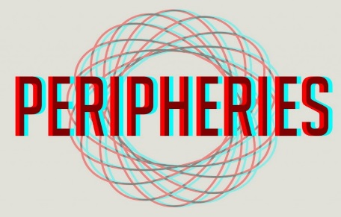
Peripheries Research & Teaching Scholarship Theme

APPLICATION FOR MEMBERSHIP (ESW applicants)
Before filling in this form, please consult the Peripheries Prospectus attached to this email to see if our orientation suits your work. You should note that Peripheries is not at this point in time a research centre; rather we are a research cluster (called a ‘theme’) within the School of Education & Social Work. Peripheries is on Twitter: @PeripheriesT and has a public Facebook group: https://www.facebook.com/groups/181937386029623/ and WordPress site https://wordpress.com/view/peripheriesresearchtheme.wordpress.com

1.PERSONAL DETAILS:

Title:
Name: SURNAME GIVEN NAMES

PROTECTED CHARACTERISTICS (UK TERMINOLOGY)- underline relevant:

Disability LGBTIQ+ BAME (Black, Asian, ethnic minority)

QUALIFICATIONS (LIST ALL):

2. EMPLOYMENT STATUS underline relevant:

T&S T&R PhD STUDENT MASTERS STUDENT OTHER

3.CONTACT DETAILS:
EMAIL: PHONE: (+ CC)
MAILING ADDRESS:

TWITTER HANDLE:

4. PARTICIPATION:
4.a. RESEARCH KEYWORDS (Up to eight keywords that describes your research interests)

4.b. WORK STREAMS: Please indicate which workstream(s) you are interested in. You can nominate more than one stream by underlining a heading. (We are currently reviewing our workstream structure, in the meantime, answering this question will give us an indication of your interests)

- PERIPHERAL GEOGRAPHIES
Territorial dynamics (des-re-territorialisation; territorial identity; Socio-spatial inequalities); Spaces of confinement (prisons, psychiatric institutions, detention/refugees); Place, symbolic violence, coexistence and potency.

- PERIPHERAL EPISTEMOLOGIES & DECOLONISATIONS
Ableism, Critical disability studies, Minority religious studies, academic dependencies, Queer Theory, Critical Race Theory; Decolonised knowledges, Buddhist studies, indigenous Theory, Critical Race Theory, Intersectionality

- PERIPERAL VARIABILITIES (HUMAN & NON-HUMAN)
Health systems/nosologies; religious ethics/philosophy; ‘race’; social care; LGTBIQ+; disability; indigenous; caste; animal lives

- PERIPHERAL PEDAGOGIES
Approaches; content; showcasing; advocacy; global classroom; open access; curriculum development

CHECKLIST:
- HAVE YOU READ THE PERIPHERIES PROSPECTUS?
- HAVE YOU FILLED IN ALL SECTIONS OF THIS FORM?
- HAVE YOU ATTACHED YOUR CV/RESUME ALONG WITH THIS FORM TO YOUR EMAIL?

Please email this form and your CV to:

Prof Fiona Kumari Campbell
(f.k.campbell@dundee.ac.uk)
OR
Dr Fernando Lannes Fernandes
(f.l.fernandes@dundee.ac.uk)

Subject heading: PERIPHERIES MEMBERSHIP

